

SPECIAL TUNING THE MGA TWIN CAM & RECOMMENDED FACTORY UPDATES v0.64 2019

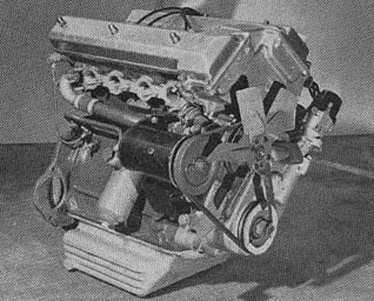

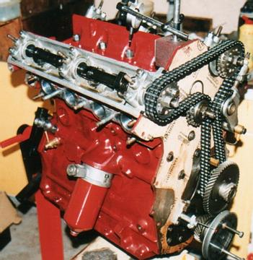

This manual is designed to be used in conjunction with membership to the MGA Twin Cam Yahoo Group when further information can be found.

Also Web Links to external companies are shown for informational purposes only and do not have any ties with the Yahoo Group or Author.

References and Related Documentation:

 | Document / Material | Location (Hyperlink/URL)
1 | Twin Cam Guide 1981 Addenda. | Where was this first published?
2 | Factory service memoranda from 1958 to 1963. | http://www.angelfire.com/rant/mgatwincam/servicememos/index.html
3 | MGA Twin Cam Yahoo Users Group | http://autos.groups.yahoo.com/group/mgatwincam/
4 | Letter from Mr R Brooklahurat to Alex Hounslow 16/03/1959 with reference to the preparation of a “Tuning Book” | Shown at the end of this document
5

Table of Contents.

1. Attention to Cylinder Head for Performance Improvement. 5
2. Larger SU Carburetors & Soft Mount Kits. 5
Soft Mounting Kits 6
SU Inlet Manifold Modification. 7
3. Air Cleaner Venturi & Air Box 7
4. Sparking Plugs 8
5. Distributor. 8
6. Rev Limiting Rotor. 8
7. Checking and Rebuilding the Engine for Racing Use. 8
Valves. 8
Valve Springs. 9
Tappets. 9
Valve Collars. 10
Valve Timing. 10
Tappet Clearance. 10
Camshafts. 10
Fitting of Camshaft Bearing Caps. 11
Bearings. 12
Distributor and Ignition Tuning (Standard Engine). 12
Distributor Clamping. 13
Over Ignition Advance due to Excessive end float on Half-Speed Shaft. 13
Running On. 14
Chain Tensioner Adjustment, Timing Chains & Timing Belts 14
Connecting Rods. 15
Engine Vibration. 16
Pistons and Rings. 16
Piston Clearance for Racing Purposes. 16
Pistons 8.3:1 Compression Ratio (Part Number AEH690). 17
Pistons 10.0:1 Compression Ratio (Part Number EXP6978) 1762cc. 17
8. Using MGB 1800 5 Bearing Block 18
9. Rear Main Oil Seal Modification. 18
10. Spin-On Oil Filers 19
11. Dynamo Pulley. 19
12. Oil pump drive spindle & half-speed shaft. 19
13. Cool Air to Carburetors & Le Mans Valance. 19
14. Carburetor Damper Piston. 19
15. Fitting Dual Weber Carburetors. 20
16. Crankcase Breather Pipe. 20
17. Oil Pressure. 21
18. Baffled Sump & Crank Scrapers & Magnetic Plugs 21
19. Lightened Flywheel 21
20. Oil Cooler. 21
21. Exhaust Headers or Extractors. 22
22. Water Loss. 22
23. Adjusting Suspension for Track Use. 23
Anti-Roll Bar. 23
Hydraulic Dampers (Shock Absorbers). 23
24. Gearbox & Rear axle. 24
Rear axle Ratios & Limited Slip Diffs. 24
axle Shafts. 24
Gearbox Ratios. 24
25. Brakes 24
Brake Pads 24
Uprating Rear Brake Cylinders. 24
26. Electronics 25
27. Appendix 25

Attention to Cylinder Head for Performance Improvement.

Outlet throat at the valve seat to 1.436”. Bore out exhaust throat at valve seat to 1.28”
When boring out the valve throats, machine them with a light cut, as a heavy cut may disturb the valve seat insert.
The boring must be concentric with the valve guide and the valve seat. If after boring out the valve throats a fraze or edge is left in the port, this should be blended into the port by grinding and polishing.
Grind away completely the inlet valve guides and bosses where they protrude into the ports so that the guides are at an angle and are smooth to the wall.
Pic of Revised Port.
More information on porting can be found in Message 15794
Fit bronze exhaust valve guides EX187/308 and ream position to give .0025” minimum running clearance (Make up locally in Ali-Bronze).(was there ever a part number for these?)
Standard and Bronze with modified oil seal guides. Also see Message No. 9006
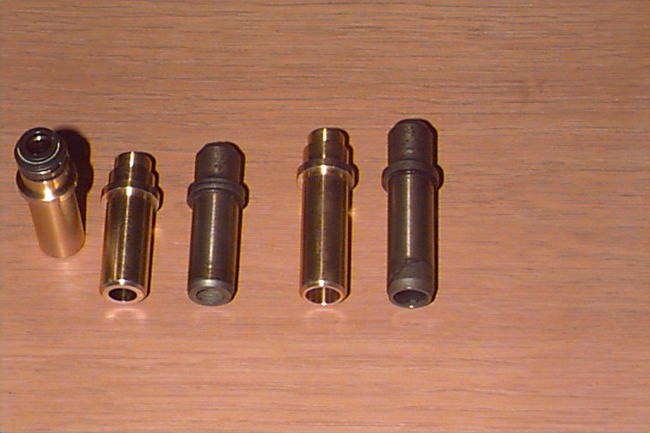
Polish all valve ports and line up the inlet manifold at the rear face with the cylinder head inlet port holes.
Radius the edge of the sparking plug holes approx 1/16” radius, around the upper part of the hole, but not around the lower edge as this will expose the plug thread.
(Insert pic here)

Larger SU Carburetors & Soft Mount Kits.
For standard engines, the fitting of 2” SU provides little improvement below 6000RPM.
Fit 2” Carburetors, AUC938. Bore out the inlet manifold to suit. These carbs are fitted with VB needles and blue and black dashpot springs.
Remove vacuum advance pipe and plug carbs with plug AUC1289 leave vacuum advance union at distributor open (If distributor Lucas No 40410 is fitted)
Fit Carburetor extensions AHH5962 (2 off)
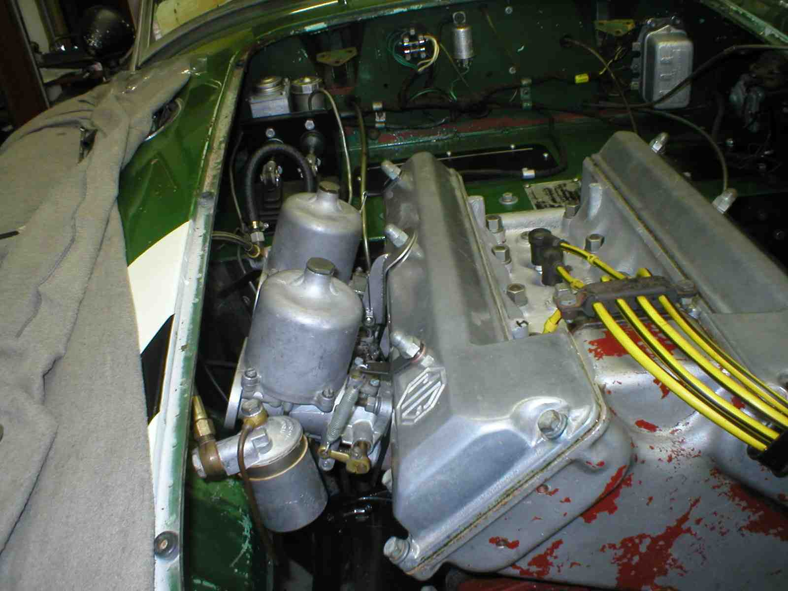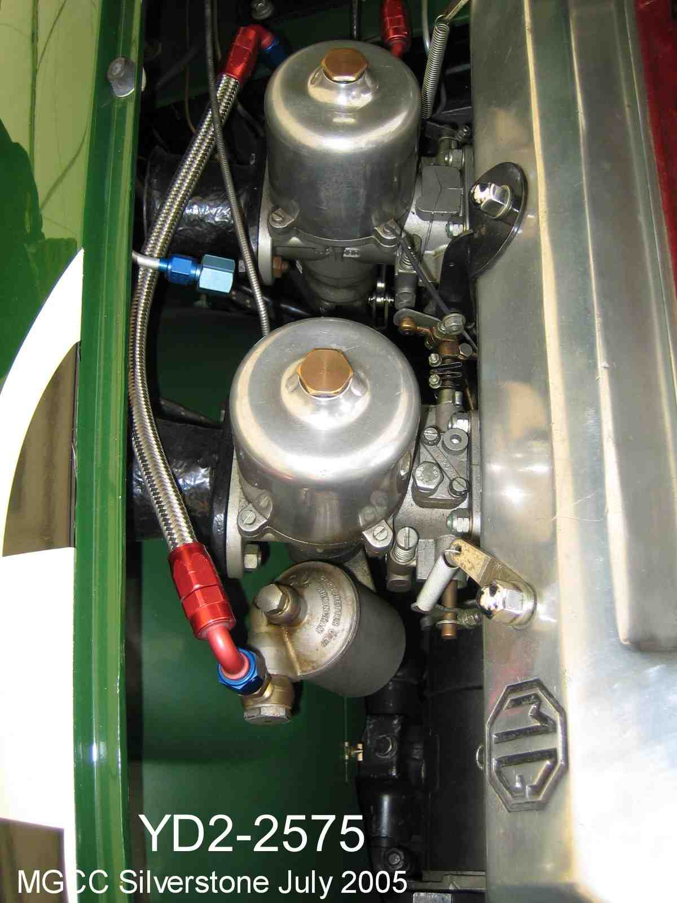

Soft Mounting Kits
To prevent vibration of the carbs. It is necessary to use a synthetic rubber gasket AHH5968 or AHH5791 between the carbs and the manifold, 3/16” thick, use double coil spring washers, with flat washers on the top under the car fixing nuts so that the carbs maybe left firmly but otherwise flexibly spring mounted. Wire the nuts in pairs to prevent them becoming slack. The standard studs may need to be lengthened before fitting this kit which is currently unavailable.

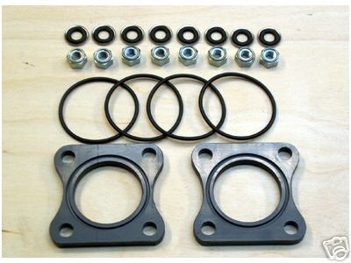
Also see.
http://autos.groups.yahoo.com/group/mgatwincam/files/Components%20Info/
SU Soft Mounts Stage 4A.pdf

You will need to make your own accelerator cable brackets AHH5994 and return spring brackets AHH5995, which can be taken up to the valve cover bolts one spring each end of the carbs. The throttle works opposite to the standard car and the leaver should be fitted inwards instead of outwards.
The carb dashpots have springs fitted. These can be removed as it should be satisfactory without them, but if the pick up is bad you may need them left in.
You might find it is necessary to improve pick up, by raising the levels in the float chambers, this can be done by setting the float levers upwards so that a 5/16” bar just passes between the underside of the lever bow and the float chamber top edges. (See Fig D13 of the Manual for illustration)

SU Inlet Manifold Modification.
Inside the ports of the standard SU manifold you will see the mounting nuts used to attach the manifold to the head. This can affect the airflow and modifying this mounting can help reduce the turbulence in this area. See message 12158. Part of the improvement obtained by fitting Webers is due to the straight flow down the chock to the valve offered by the Weber manifold over that of the SU’s. From the pictures below, the early left hand manifold has had domed Ni-lock nuts fitted and the Right hand later manifold has had a recessed Allen bolt fitted. The early SU manifold is shown on the left and the later on the right. Although an exact changeover point was never documented, as a guide YD3 816 (G430) has the early manifold with the extra lugs and YD3 1189 (G833) as the later manifold. It is suspected that the early manifold was designed for either another type of SU, Solex carbs or even Lucas fuel injection.
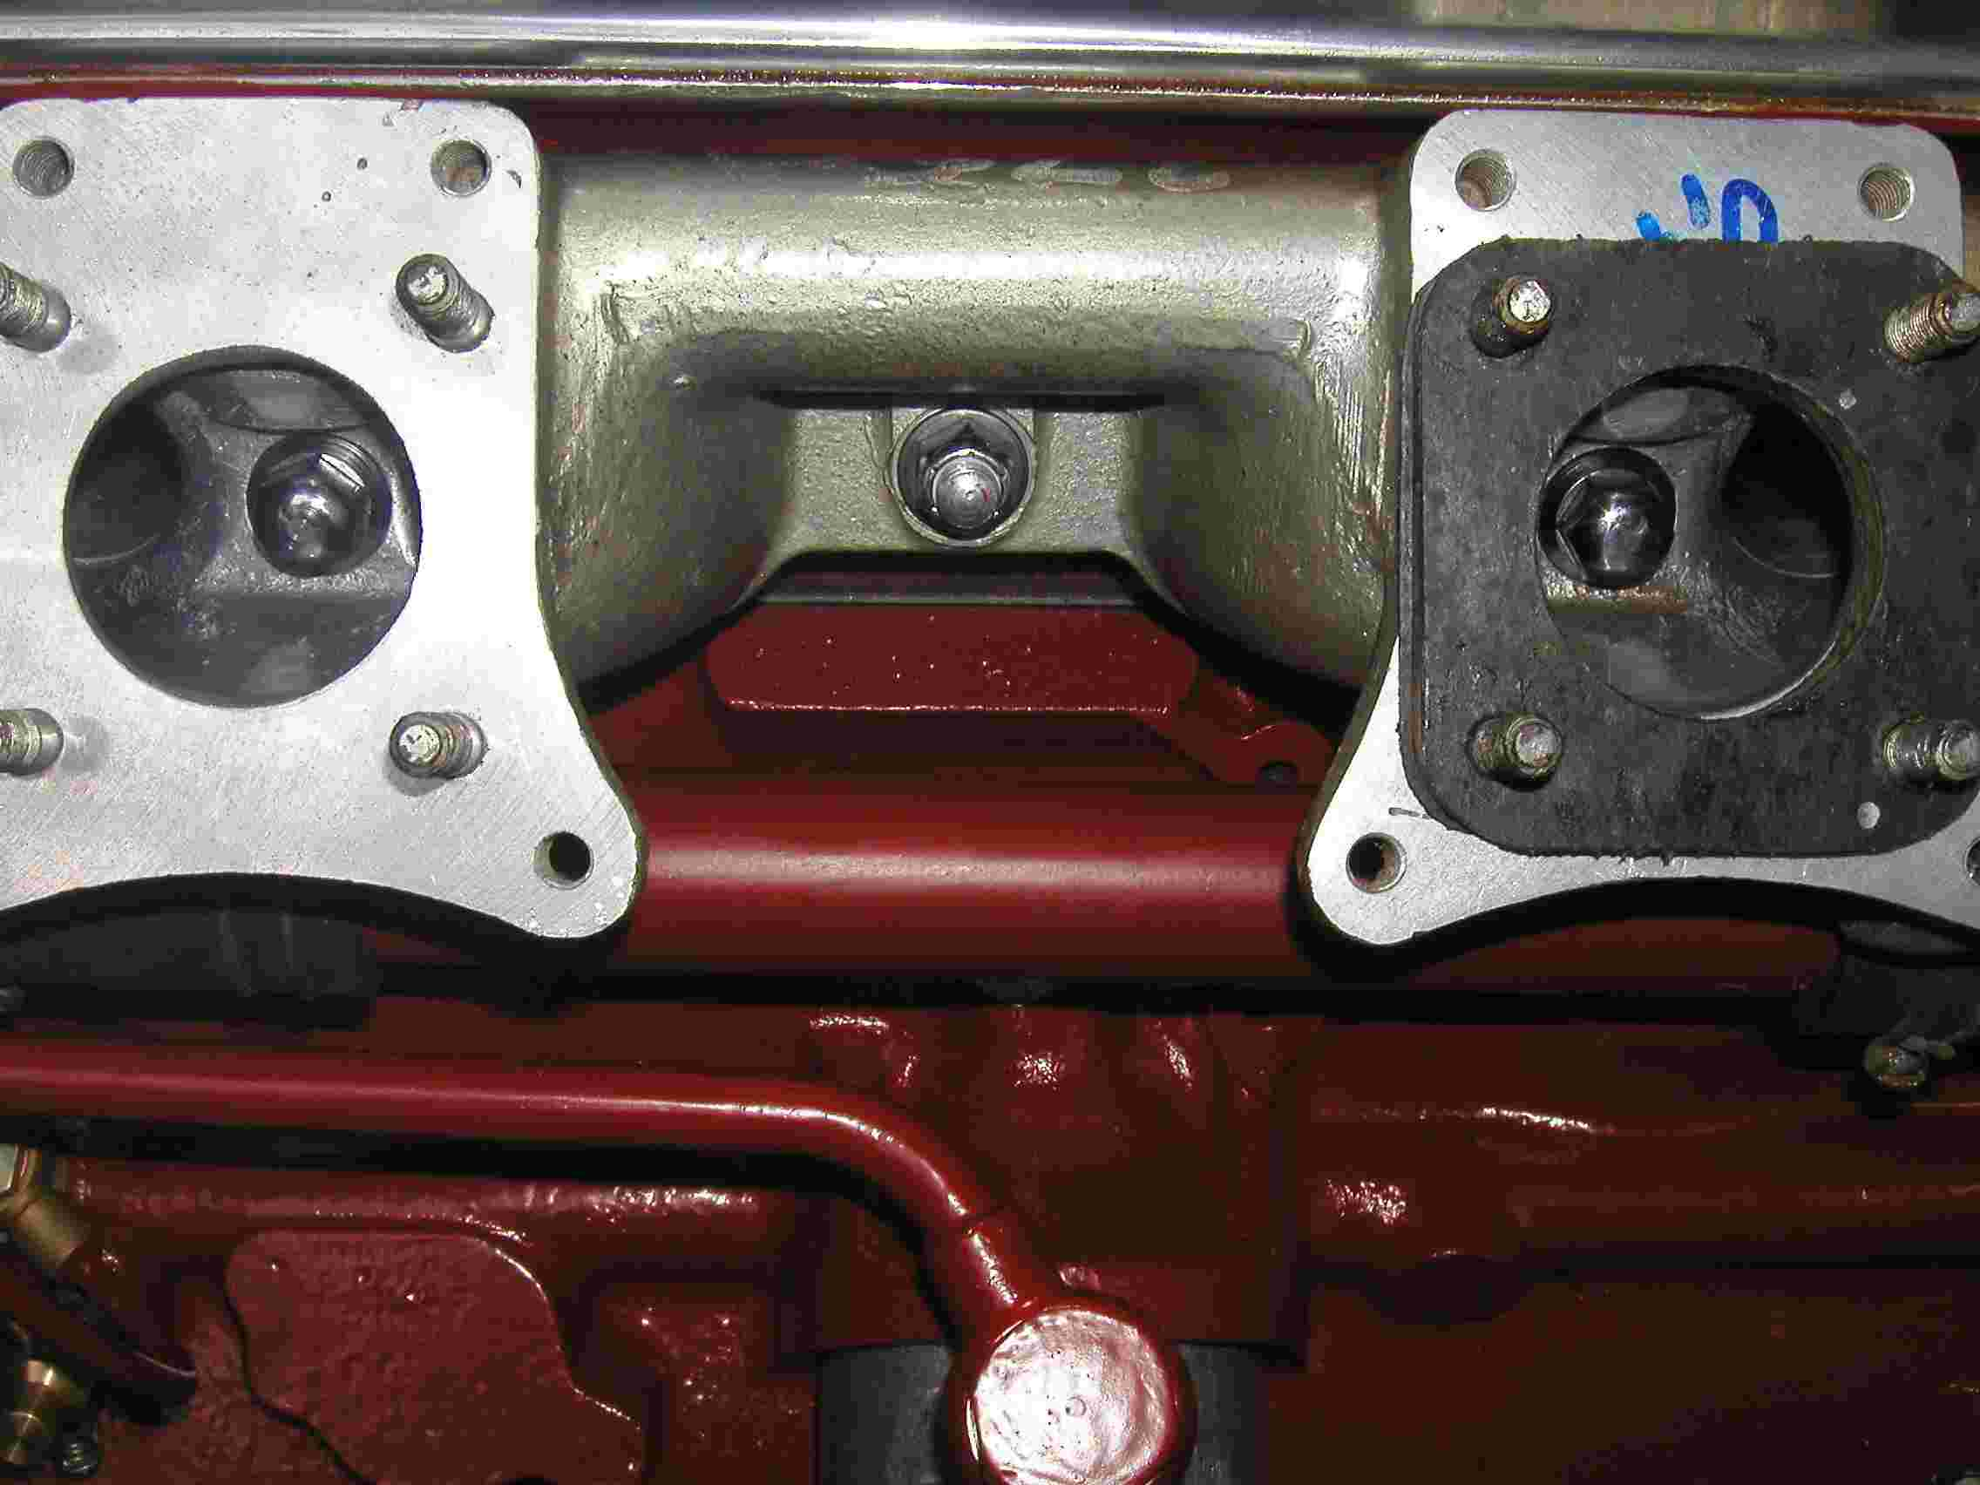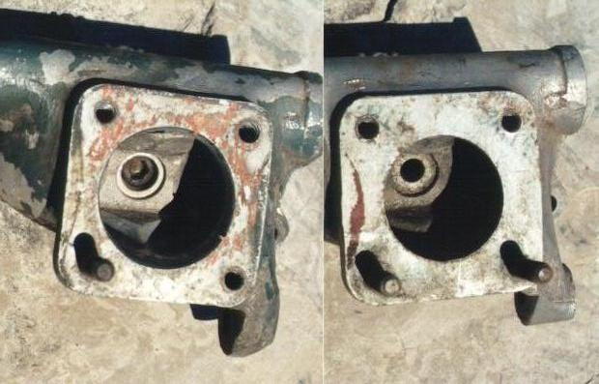

Air Cleaner Venturi & Air Box
From Service Memorandum MG/286.
A venturi was fitted to the Twin Cam air cleaner from chassis number 2468.
The venturi I.D. is 42.5 mm.
The length of tube comprising the venturi is 37mm.
This tube is parallel with no taper and flared on the entry end.
Entry flare radius is approximately 3 mm.
The hole in the air cleaner back plate is flanged where it is punched and the
venturi tube pushed in and spot welded in place.
Clearance from the venturi opening to the metal strip between the outer cover
bolt holes is about 23 mm.
As with most racing cars, a forced air induction can be achieved by fitting a sealed airbox connected to the front of the car, to produce positive or a rammed air effect. This also allows for colder denser air to be forced into the carbs also.
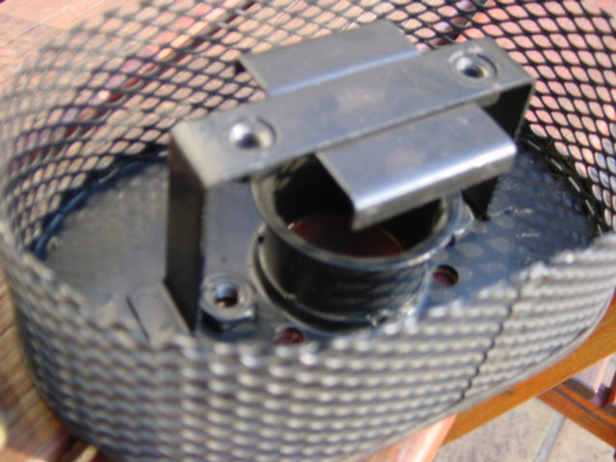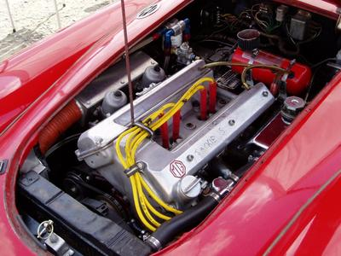

Sparking Plugs
Standard Spark Plugs was Champion N5 but in May 1959 MG recommended changing for road cars to Champion N3, as per service memo MG/253.The modern equivalents being xxx or yyy.
Sparking plugs must be Champion N58R for competition work.
(What’s the modern equivalent ?)

Distributor.
If the latest distributor AEJ41 (40718) is fitted to above tuned engine the static setting required is 4° B.T.D.C. with high compression pistons. It is desirable to use the distributor AEJ41 (40718) replacing 40510.
I myself have two twin cam distributors 40718A and 40718E
There maybe even a third type of distributor Lucas no. 40692 but this is unconfirmed.
The factory issued a “Campaign Change of Distributors” See Service Memorandum MG/301, so your car may have had is distributor replaced. AEJ41 was fitted to selected chassis numbers and as standard from Chassis No 2222 onward.
Before fitting the new distributor, it is essential that the distributor drive gear should be checked in accordance with Service Memorandum MG/296

Rev Limiting Rotor.
Lucas Rev Limiting rotor is also recommended, which limit’s the revs to 7000rpm NOS Lucas DRB108 54424982
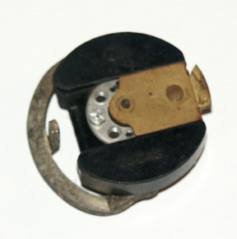

Checking and Rebuilding the Engine for Racing Use.

Valves.
Larger inlet & exhaust Valves are obviously possible.

Standard Sizes are:
Inlet valve standard 40.53mm
Exhaust valves standard 36.86mm

From Yahoo Message 20003 FIA appear to have sanctioned for racing:
+ 44mm inlet valves
+ 40mm exhaust valves

A common modification is to use:
42 mm inlet and 37 mm exhausts.

Typically it’s harder to get the gasses into the combustion chamber than it is to remove them. Hence enlarging the inlets more that the exhaust valves. This is certainly the case with pushrod MGB engines.
Below is a photo of a http://www.gsvalves.co.uk/ 42mm Inlet valve which weighs 92 grams.
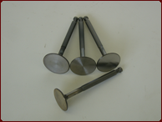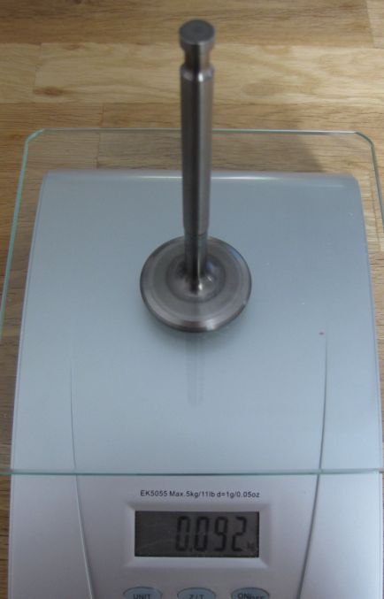

Valve Springs.
Valve Springs outer part number AEH668 and inner AEH669 should be fitted so that with the standard camshafts these give a minimum valve crash position of 7400rpm after continual use. AEH668, 138lbs and AEH669, 72 lbs open.
The above springs are now fitted as standard fitment from chassis number 2251.
As a quick check the free length of a standard later type spring should be:
Inner: 2.415”
Outer: 2.695”
More Valve Spring info can be found here.
http://autos.groups.yahoo.com/group/mgatwincam/files/Components%20Info/
Valve Springs.PDF

Tappets.
It would be desirable to use the latest tappet bucket AEH677 if not already fitted to your engine. As Shown in the middle of the picture below.
These can be identified by a 5/64” by 45° chamfer the outer edge of the top surface.
These are in use in conjunction with cylinder heads fitted with tappet sleeves (commenced at engine number 1587).
Old type heads can be bored out and fitted with these cast iron sleeves AEH657 and locked in position with screwed plugs AEH658.
More information on tappets can be found in message xxxx.
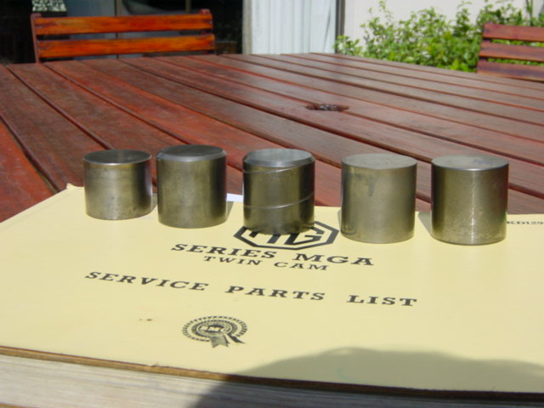

Valve Collars.
To increase the durability of the valve mechanism it would be preferable to use the latest hardened top valve spring cup AEH564. You can ascertain if soft ones are fitted to your engine by checking with a fine file. The harder ones are light grey and will have a hard greasy surface when rubbed with a file.
While the standard pushrod engine is fitted with harden valve spring caps the Twin Cam engines were not until almost the termination of production of TC engine. (Engine number???)
More info can be found in message 10611
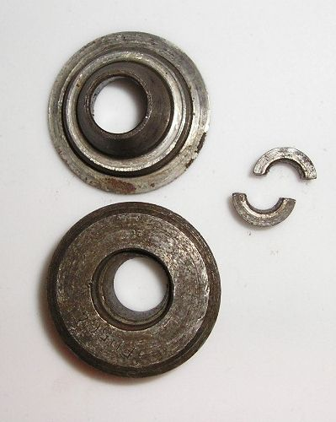

Valve Timing.
The valve timing (When checked at 21thou tappet clearance) is: Inlet opens 20° BTDC; closes 50°ABDC; Exhaust opens 50°BBDC and closes 20°ATDC.
The only requirement to set valve timing is to put the crank on TDC No. 4, pull the timing chain tight around the lower timing sprocket, over the idler and tight around both camshaft sprockets, put the locating keys in the sprocket and adjust the verniers to coincide. As a new chain stretches with running the timing does go off the correct position and it is sometimes advisable to reset when the chain settles down.

If the Distributor gear is not fitted number one TDC and Number four TDC are the same thing. Once the Distributor gear is fitted there are separate TDC's for number one and number four.
The camshaft timing slots are set on number four TDC.

Tappet Clearance.
The running clearance at tappets (cold) is 0.014/0.015” with standard camshafts

Camshafts.
Camshaft breakage can occur due to incorrect bolting down of the camshaft bearing caps.
Overloading may also occur if more than the recommended tappet settings of 0.014 to 0.015” are used.
Whilst over the years Camshaft manufacturers were a plenty, these days only a few suppliers remain. These include XXX, YYY & ZZZ
A popular street performance Camshaft XXX L14 camshaft, available in both new and reground camshafts. Rough performance gains are shown in the Appendix.
Enter L14 here for the specs of this profile, also note that I does not mention MGA Twin Cam specifically, but it is still available.
There are a variety of standard camshafts also these include:

See messages (11351, 6982, 19839)

AEH830 Inlet/Exhaust (not sure)
Clausager Page 60 refers to the first 40 cars having different camshaft profiles, but this has never been proven and the part numbers are unknown. This article probably comes from USA Sports Cars Illustrated June 1959 Page 50 part number page 51
Inlet camshaft AEH579 with casting mark of AEH580.
Exhaust camshaft AEH581 with casting mark of AEH582.
AEH579 Inlet Cam
AEH580 Exhaust Cam
AEH581 Exhaust Cam
AEH582 Inlet Cam

Early Standard Cams (possibly first 40 engines from USA SCI June 59)
Inlet 35/65 with .375 Lift, Duration 280 Degrees
Exhaust 65/35 with .375 Lift, Duration 280 Degrees

Production Standard Cams
Inlet 20/50 with .375 Lift, Duration 250 Degrees
Exhaust 50/20 with .375 Lift, Duration 250 Degrees
L14 35/67 67/35 Duration 282 Degrees

L1 47/79 71/55 with .415 Lift, Duration 306 Degrees

L14 Cam was fitted to the inlet side of the engine only. In essence, the 'Le Mans' profile is the same as an L14, which is interesting in itself.

Special camshaft timing may have been used by the Competition Department, but no record exists. This is particularly the case for the record breaking supercharged cars.
Of interest is that the factory definitely did produce cams with different profiles - they are listed as being FIA homologated (along with their respective part numbers)

ISKY TCM2 cams and DeLong tappets 17-57 degrees and 57-17 degrees with 0.404 lift and clearances
of 0.012" intake and 0.014 exhaust. From message 6920
URL…….
Note: Contact with the Valve & Piston can occur with the standard camshaft if not properly adjusted, thus Camshafts with more lift may increase this likelihood.


Fitting of Camshaft Bearing Caps.
The following procedure for tightening the cap nuts should be followed to ensure that no distortion of the camshafts occurs.
Set the camshaft at 90° BTDC on No1. cylinder. This is to give enough clearance between valves and pistons.
When fitting the camshafts bearing caps the camshaft should be positioned so that the timing slots in the cap and the shaft are approximately in line.
To prevent camshaft distortion a regular sequence of tightening the cap nuts should be used. It is essential to commence at the front cap to ensure that the camshaft thrust flange enters the thrust slot in the cylinder head cleanly. When removing the caps it is again essential to follow the above sequence to ensure a clean withdrawal of this flange.
Finally any slight adjustment to the camshaft should be made to enable the timing keys to be fitted and the crankshaft turned to TDC on No1 cylinder ready for timing the engine.
Service Memorandum MG/251 reads better than the above !!!
(Insert pic here of engine with cam cover off and put numbers on the pic)

Bearings.
VP3 (copper lead, indium Flashed) bearings are used throughout, except for white metal camshaft bearings. No trouble should be experienced with bearings, except in cases of dirty engines caused by bad maintenance etc.
To ensure perfect running and condition of bearings the engine must be assembled spotlessly clean.
Clean out all oilways and squirt out with kerosene, wash all parts with kerosene and brush and wash all with high-pressure water, drying off thoroughly.
Do not clean items with emery paper unless you make sure of eventually cleanliness.
Do not do grinding or polishing adjacent to the assembling work.

Distributor and Ignition Tuning (Standard Engine).
It is important that the ignition timing is not advanced beyond the engine requirements or excessive combustion temperatures will occur with consequent damage to the engine.
The standard static setting of the distributor is TDC (High Compression Engine only). But it is preferable to check the engine (with a stroboscope equipment) to ensure that the advance does not exceed 26° crankshaft at 5000rpm, if it does so it is permissible to retard the static setting TDC as far as 3° ATDC to obtain this result.
The original standard distributor, which has a vacuum advance unit, is Lucas No. 40510 (static setting TDC) and has 22/26° auto advance.
The later distributor now fitted, which has an improved roller weight mechanism and no vacuum advance unit is part number AEJ41 (static setting TDC) and has 24 to 28° auto advance (Lucas part No. 40718).
For competition high output purposes it is desirable to have distributor AEJ41.
If you replace the HT leads, use racing quality material.
For racing the plug suppressors maybe removed and racing push on plug terminals fitted.
On fitting distributor AEJ41 to early cars, remove the vacuum advance pipe and plug Carburetor union with plug AUC1289.
Later Curve of AEJ41 40718 Distributor, but if you look carefully you can see the curve of 40510 penciled in.
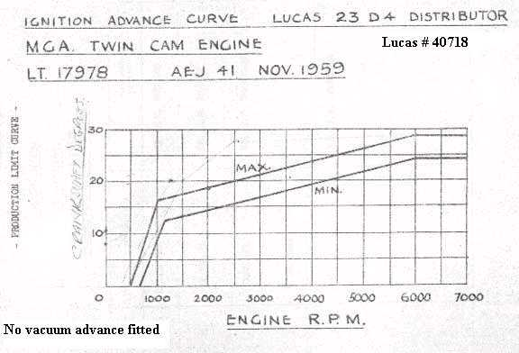

Distributor Clamping.

Excessive wear has occurred on the distributor driving gears on some engines, this is due to misalignment of the distributor with its drive, causing a tightening up of the distributor shaft and consequently excessive gear wear.
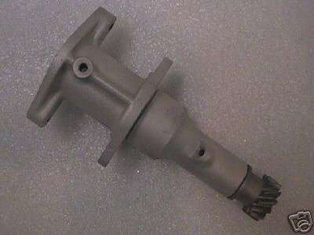
The misalignment of the drive is due to incorrect method of tightening the clamp, the tightening of the two set bolts holding the plate first and then the clamping bolt last will bring about this misalignment of the distributor and its drive.
The correct method is to leave slack the two bolts holding down the clamp to the distributor drive housing, finally tightening following the clamping screw adjustment, then no stickiness or misalignment will take place.
It would be advantageous to give the engine a few turns with the two holding down bolts slackened off to allow alignment to take place after any adjustment of clamping screw is made.

Over Ignition Advance due to Excessive end float on Half-Speed Shaft.
The standard limits for end float of the half-speed shaft should be between 0.003 and 0.006”. If due to ware the end float exceeds 0.0010” shims must be removed from behind the thrust plate to obtain the standard limits. Excessive end float of the half-speed shaft over advances the ignition but wear between crank and the half-speed gear wheels retards ignition.

On the subject of half of Jack shaft it should be noted:
Check the number of teeth on the oil pump drive spindle and the matching gear on the half speed shaft.
If the oil pump spindle has 10 teeth the shaft must have 9 teeth. If the oil pump spindle has 11 teeth the shaft must have 10 teeth.
See CSM MG/240 and Workshop Manual A.39

Sports Car Spares were offering half speed shafts with an additional oil feed hole to improve lifespan.

Running On.
It must be ensured that no sharp edges of any kind are present in the combustion chamber, especially around the sparking plug aperture.
Carburetors must be set to give the minimum slow running (XXX Rpm), with accurate and equal setting of each throttle plate.

Chain Tensioner Adjustment, Timing Chains & Timing Belts
To prevent any possibility of the chain adjusting bolt stripping (due to over tightening) in it’s housing and the chain jumping the sprockets, it may be thought advisable to modify the adjuster housing by boring the housing and making up and pressing in a small steel insert (S.K. 7237)
4 Page Document on this problem on the yahoo site:
Files > Components Info > Engine_Components > Timing_Chain_Tensioner

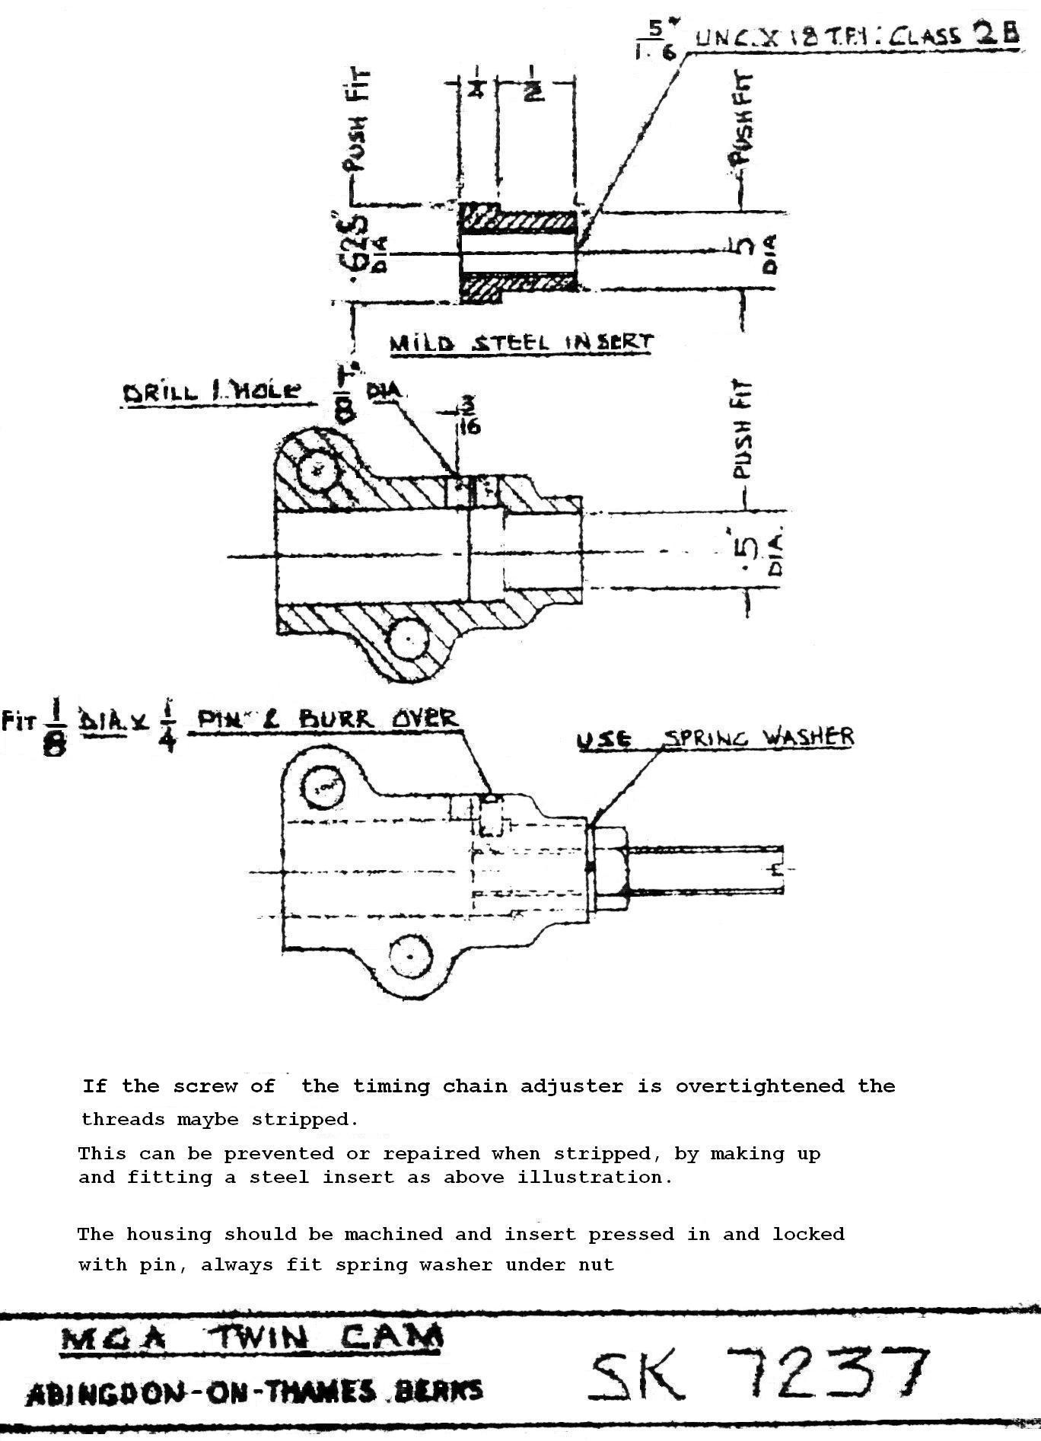
There are two types of timing chain, those with a link (Master Link) and those without (Endless Loop). Whilst the Master Link one’s maybe easier to install, the link itself can offer a weak point. More info can be found in messages 12285, 7701.
Several manufacturers still exist, including the Original Renold. Also Rolon
http://www.renold.com.au/
Some other manufacturers may offer chains which are not true BS sized chain i.e. a metric equivalent, these must be avoided.
Converting from a Timing Chain to a Drive Belt has also been attempted, but this is an extremely complex procedure. More information can be found in messages 10775 & 6283.
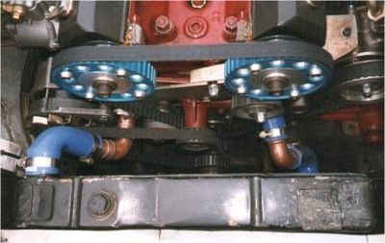

Connecting Rods.
Torque up your connecting rod bolts to the correct figures on the data sheets (xxlbs).
There are two types of Twin Cam Con Rods. Those before engine No. 1343 and those after. These were introduced to improve balance and strengthen the big-end.
The early type is individually weighted (889.47 grams) and stamped plus or minus 1oz (28.35 grams) over or under this weight. See Service Memorandum MG/236
The later type has heavier bearing caps and extra metal at the small end, for balancing and no weighting is necessary. From Service Memorandum MG/262
For racing purposes it is preferable to use the latest type rod or better still Carrillo Rods.
The part number of the later rods are AEH642 (RH) and AEH644 (LH), you can recognize these by the two balancing lugs, one each side of the gudgeon pin boss, these lugs have a width of 1 ¾” approx.
Is this correct Message 7900 says AEH 645 & AEH 643 also from message 7886
The older rod is shown here on the left and the newer on the right.
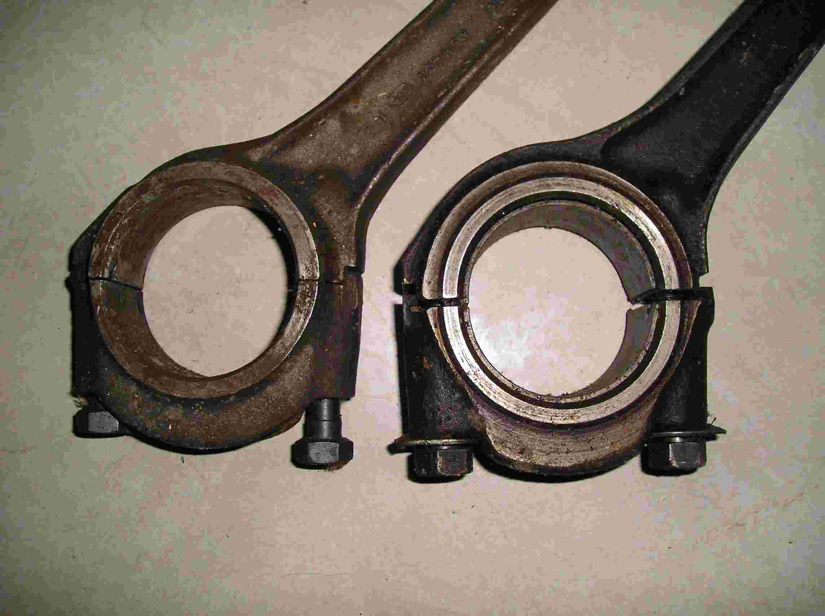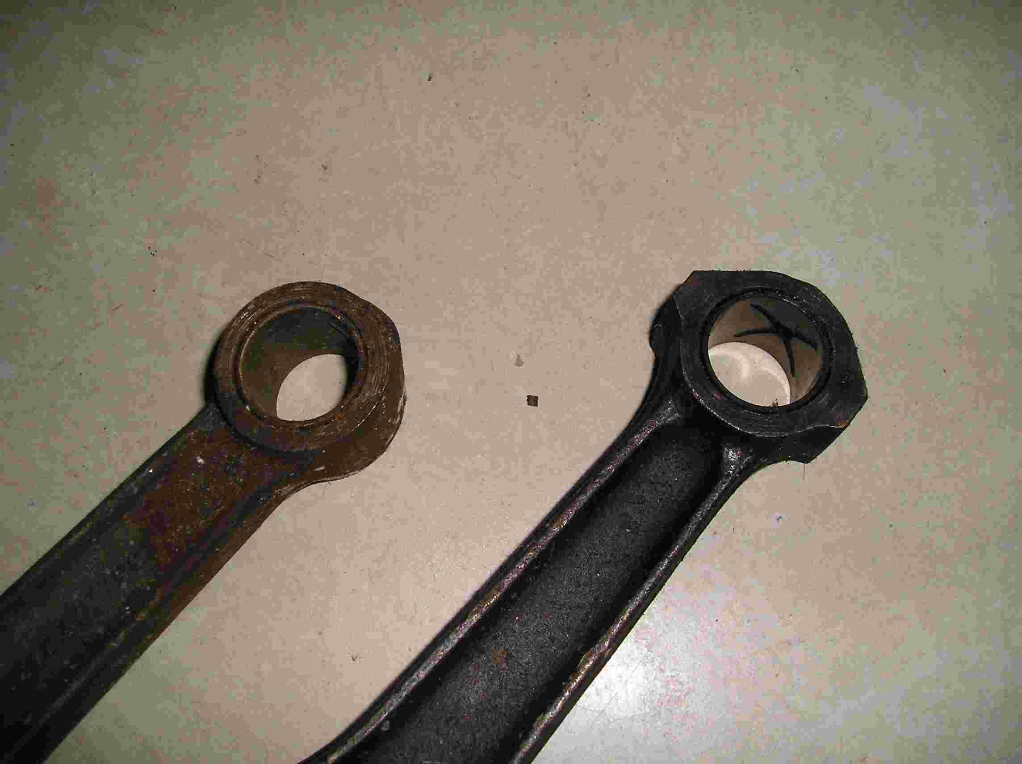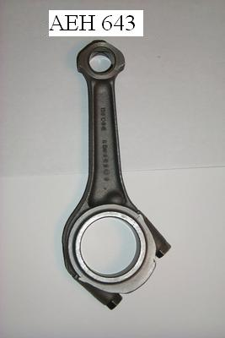

Carrillo make two types of MGB Rods.
www.carrilloind.com/

H-Beam Rods Part # 66500H
S-Beam Rods Part# 66500S

The weight of these rods is significantly reduced S-Beam example:
Total Weight =588 grams (Rotate = 418 & Reciprocating 170)

So if you consider a standard rod weighs almost 890 Grams these are 33% lighter

These are the standard 6.500 “ long rods, but many people are now fitting 7” rods to reduce piston weight and piston rock at the top of the bore.

Engine Vibration.
- It is usually to experience some vibration at 5500rpm. A torsional vibration at low speeds is always there but should not prove troublesome.
- The most likely cause of excessive amount of vibration is ‘out of balance’ of the clutch.
Turning the clutch around 180° often effects a big improvement.
The clutch should be balanced to within ¼ oz in.
If turning the clutch round 180° produces no improvement then individual checking of the balance of crankshaft, flywheel and connecting rods should be undertaken and correction made accordingly. The crankshaft should be within ¼ oz in. and connecting rods within two grams overall weights. The whole assembly of crankshaft, flywheel and clutch unit balanced should be within ¼ oz in.
- Balancing of propeller shaft. Disconnecting at the coupling flange and moving around the shaft 180° may show an improvement in vibrations affecting the gearbox.

Pistons and Rings.
To ensure reasonable oil consumption, check that the pistons are fitted with the twin rail scraper ring part number AEH672, including the spring expander ring fitted behind it part number AEH680.
The top compression ring is chromium plated for prevention of the bore wear, but If desired a plain ring part number AEH682 maybe fitted in place of this to further improve the oil consumption or prevent plug fouling with the racing N58R plugs.

Piston Clearance for Racing Purposes.
To allow for increased expansion under high output conditions, it is advisable to increase the ovality (or clearance of the piston short at the gudgeon pin sides).
The standard ovality of the piston skirt is 0.004/0.006” at the bottom of the skirt to 0.008/0.010” at the top of the skirt both measuring on gudgeon pin axis.
It is possible to very carefully set the pistons up in a lathe, machining one side at a time and increase the ovality to 0.012/0.013” at the bottom of the skirt and to 0.016/0.017” at the top of the skirt, leaving an unmachined portion all down each side of thrust face approximately 1” wide. Polish edges where machining runs out at thrust faces.
Note: The standard piston of 9.9:1 compression ratio is part number AEH681 to modification3, with skirt ovality of 0.004/0.006 – 0.008/0.010” and these were fitted to most engines, but new pistons now supplied as spares to part number AEH688 and 9.9:1 C.R. have skirt ovality of 0.012/0.014 – 0.016/0.018” these are also round top pistons.
In the early days Piston failure was quiet common. There is a pole setup on the Yahoo site, where you can register which piston experienced failure if you have suffered from this. Currently approx 80% of piston failures occur on No.3 Cylinder.
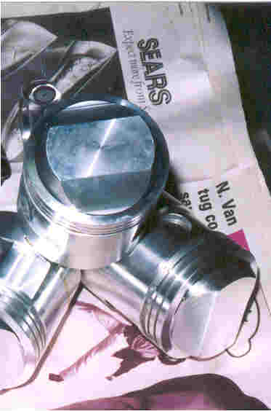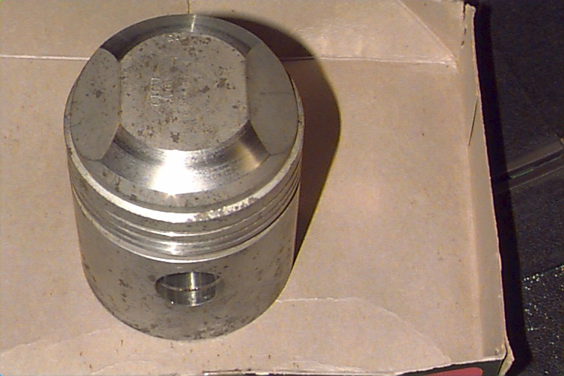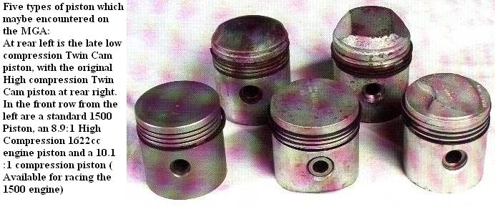
Hepolite part numbers:

Part# 15414 for the low compression 8.3:1 piston type.
Part# 14684 for the high compression 9.9:1 piston type.

Pistons 8.3:1 Compression Ratio (Part Number AEH690).
Note these pistons have a stepped lower compression ring, the undercut being fitted towards the bottom of the piston, this acts as a scraper in reducing oil consumption.
The top ring is plain high tensile cast iron, not chrome plated.
These pistons produce a smoother engine for general use and the BHP is still over 100.
The ignition static setting with these pistons and a distributor AEG41 is 8° BTDC.
The sparking plugs to be used are Champion N3 or N4.
(Are N3 & N4 still available – Use Champion or NGK ….)

Pistons 10.0:1 Compression Ratio (Part Number EXP6978) 1762cc.

From Yahoo Message: 20061
On the pages for EX187 Twin Overhead Camshaft Version of M.G.A. with Disc
Brakes there are over 300 drawing numbers listed. In any event Number 310 has Date 26 6 59 and Name PISTON FOR 3 1/8" BORE BC.16.GB 3 1/8" equals 79.375 mm. This would seem to be the origins of the 1762cc configuration.

1762 cc pistons with a standard head gives exactly a 10.0 to 1 comp ratio.
SRX 210 run at Le Mans at 1762 cc perfectly legally (GTP under 2 liters Class)
Part Number EXP6978 was a works piston manufactured for BMC by Hepolite in Birmingham - 79.4mm giving 1762cc several sets were produced.

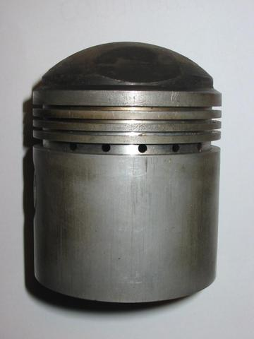

Using MGB 1800 5 Bearing Block

Either for a performance enhancement or if your existing block is irreparable. The MGB 5 Bearing blocks can be mated successfully to the MGA Twin Cam head and ancillaries. This is a lengthy undertaking and further details can be found in message 7797 on the yahoo site.
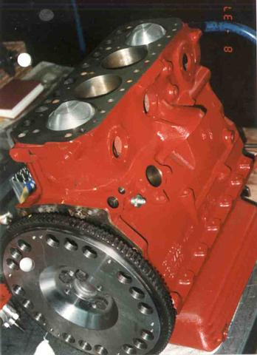

Rear Main Oil Seal Modification.
I believe this is the message that goes with this picture !!!
See Message 10229
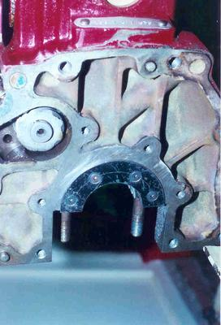

Spin-On Oil Filers
Many companies have long offered the Mocal spin-on oil filer adapters which utilize modern paper type filter. Search for part number FC289 or MOC289 or try here.
http://www.thinkauto.com/acatalog/Price_List_Spin_on_oil_filter_conversions_26.html
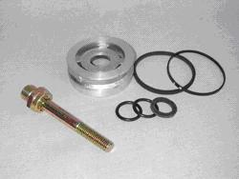

Dynamo Pulley.
To increase the dynamo charging rate at any given engine speed a smaller dynamo pulley (Part No. AEH605) and a shorter fan belt (Part No. AEH621) were introduced at Engine No. 272. This modification raises the dynamo/crankshaft pulley speed ratio to 1.2:1. From Service Memorandum MG/237A.

Oil pump drive spindle & half-speed shaft.
The number of teeth of the oil pump drive spindle increased from 10 to 11; Tooth-angle of half-speed shaft modified to suit. (Interchangeable together only) from Engine number 315. From Service Memorandum MG/240.

Cool Air to Carburetors & Le Mans Valance.
On the right hand side of the radiator grille, a hold maybe cut in the body approximately 4” diameter and a tube maybe bolted into this flange. The inner flexible air hose maybe fitted and clipped over this pipe to ensure a separate and slightly forced cool airflow over the Carburetors.
You may also notice from the car shown below the Le Mans style front valance. This is still available from MGOC and others in fiberglass. Fitting it requires the front bumper mounts of the front chassis extension to be removed. The two outer ones can be unbolted, but the inner two require cutting off unless they are to remain as towing hooks.
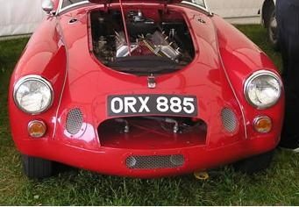

Carburetor Damper Piston.
The original damper (AUC8103) could cause uneven running and a restriction in maximum speed but are interchangeable with the new ones (AUC8114) giving an improved performance. Modifying AUC8103 to the later spec is described in Service Memorandum MG/264.

Fitting Dual Weber Carburetors.
This has long been a popular modification to Twin Cams and was offered as a factory option.
40 DCOE Weber jetting info can be found here.
http://autos.groups.yahoo.com/group/mgatwincam/files/Components%20Info/
Weber Jetting Information.jpg
45 DCOE Webers have also been fitted, but no jetting info is available and would only be recommended for the most highly tuned engines, or 1800+ cc engines.

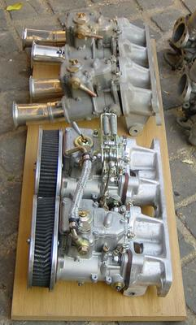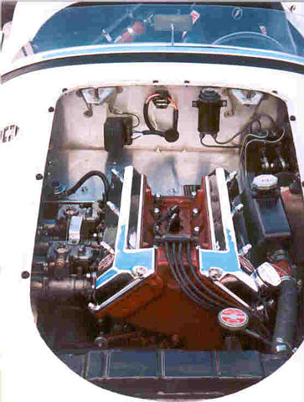

Crankcase Breather Pipe.
In cases where oil has been lost through the breather system during hard cornering the following modification incorporating further vent pipes, which are interchangeable in sets, will improve this condition and reduce oil consumption.
Remove parts 12H155, cylinder side cover rear complete, 1A2202, Rear elbow for cover, 1A2201, rear baffle for side cover, 1H874, elbow for vent pope, 1H875, pope for elbow vent pope end, 1H876 pipe elbow side cover end.
Remove parts AEH584, heat shield assembly for cylinder side cover, AEH586 asbestos sheet for heat shield, AEH628, crankcase vent pipe, 1G1309, clip for crankcase vent pipe. Replacing with AEH684, heat shield assembly for cylinder side cover, AEH683, asbestos sheet for heat shield, AEH662, vent pope complete, AEH661. Vent pope and reuse 1G1309, clip for vent pipe.
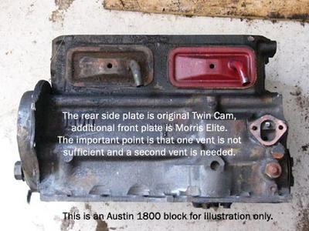

Oil Pressure.
For racing purposes it is advisable to increase the oil pressure. This can be done by packing the oil pump release valve spring with a packing of 0.02” thick by ½” diameter.

Baffled Sump & Crank Scrapers & Magnetic Plugs
Baffled sumps are obviously used to reduce oil surges during extreme cornering and braking. An example is shown below.
Crank Scrapers seem to be the flavor of the month and there is much written about their benefits. The basic principle is to reduce the oil sloshing around in the sump, by wiping or scraping if off the revolving crank and thus reduce the drag on the crank as it revolves. Much like converting to Dry Sump. The down side obviously is some of this material coming loose and clogging the oil strainer.
Magnetic sump plugs however don’t seem to have a down side and many modern oil filters now incorporate a magnetic element built in. Analyzing the used engine oil can reveal many things, but this is an expensive process. Magnetic plugs will give you a rough idea of what’s wearing out and may prompt you to do further investigations, but they wont capture none magnetic material.
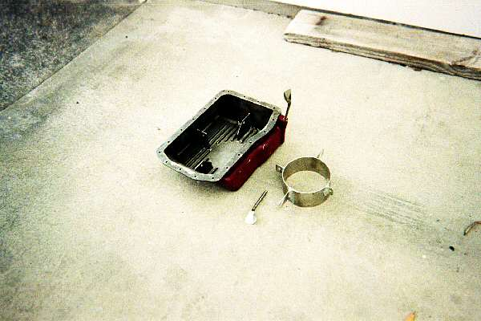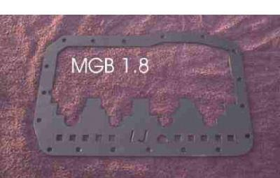

Lightened Flywheel
Lightened flywheels have long been a favorite mod from racing. These days aluminum flywheels are readily available. However this will effect idling.

Oil Cooler.
For racing purposes an oil cooler should be fitted, list of parts are ARH113 oil cooler, AHH5883 pipe, AHH5884 oil pipe block to cooler, AHH5885 oil pipe cooler to filter, AHH5886 support bracket for cooler pipes, AHH5887 clip for cooler pipes, AHH5902 packing for oil cooler and various nuts, bolts and washers, SK7203 sketch showing mod to front apron for cooler fitting and horn positioning, A7101 arrangement of oil cooler.
Late Type fitment diagram
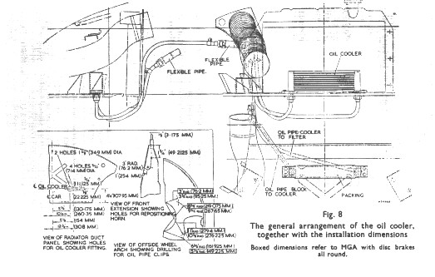

Exhaust Headers or Extractors.
The twin cam engine is no different to other cars, extractors are still available, however LHD cars make it much more difficult due to the position of the steering column. Extractors can offer a few extra BHP over the standard item, but the standard cast exhaust manifolds are quite good anyway, however the big saving is in weight. What is more useful is covering the exhaust manifold in a heat proof tape, or hot jet coating the manifolds. This keeps the gasses hotter for longer allowing them to flow down the manifold away from the engine faster. Also general engine bay temperature is reduced, always a good idea with MGA’s.
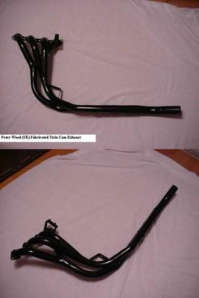

Water Loss.
It is extremely unlikely, but if water loss is found to occur under high ambient temperatures and racing conditions, it maybe alleviated by fitting a 3/8” bore pipe from the center plug in the cylinder head around the rear of the cylinder head and forward into the heater connection hole in the thermostat housing. Clip the pipe so that it does not vibrate.
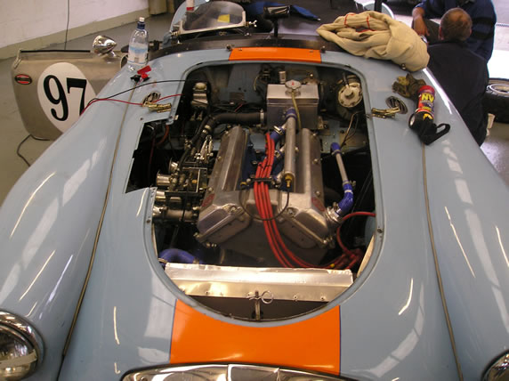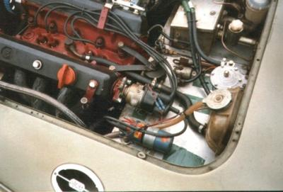

Below is a photo of an Ex Works Header Tank fitted to cars 627, 932 & 2573. The pipe from the back of the tank runs to the center plug in the cylinder head. Thus hot water coming in went to the front of the tank. As you see all the nuts, bolts and pipe fittings are drilled for wiring, the wiring is still there for the filler bolts.
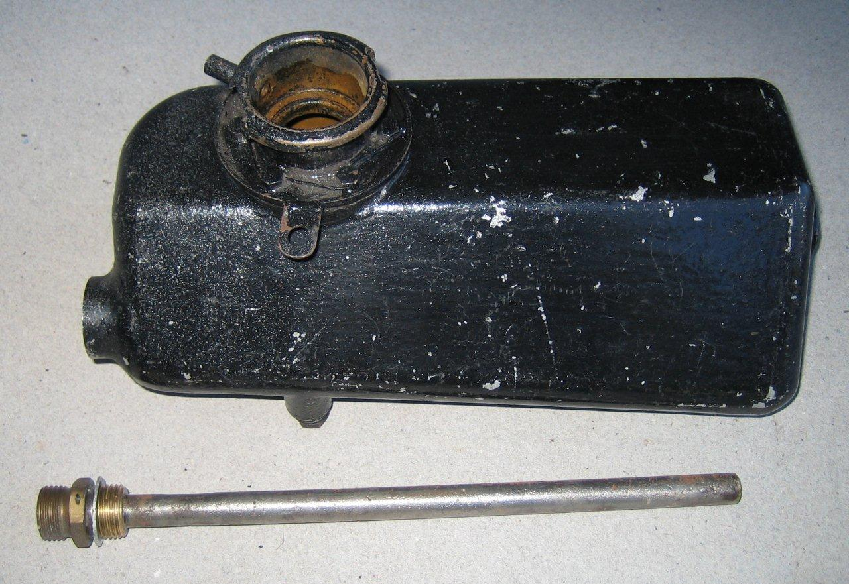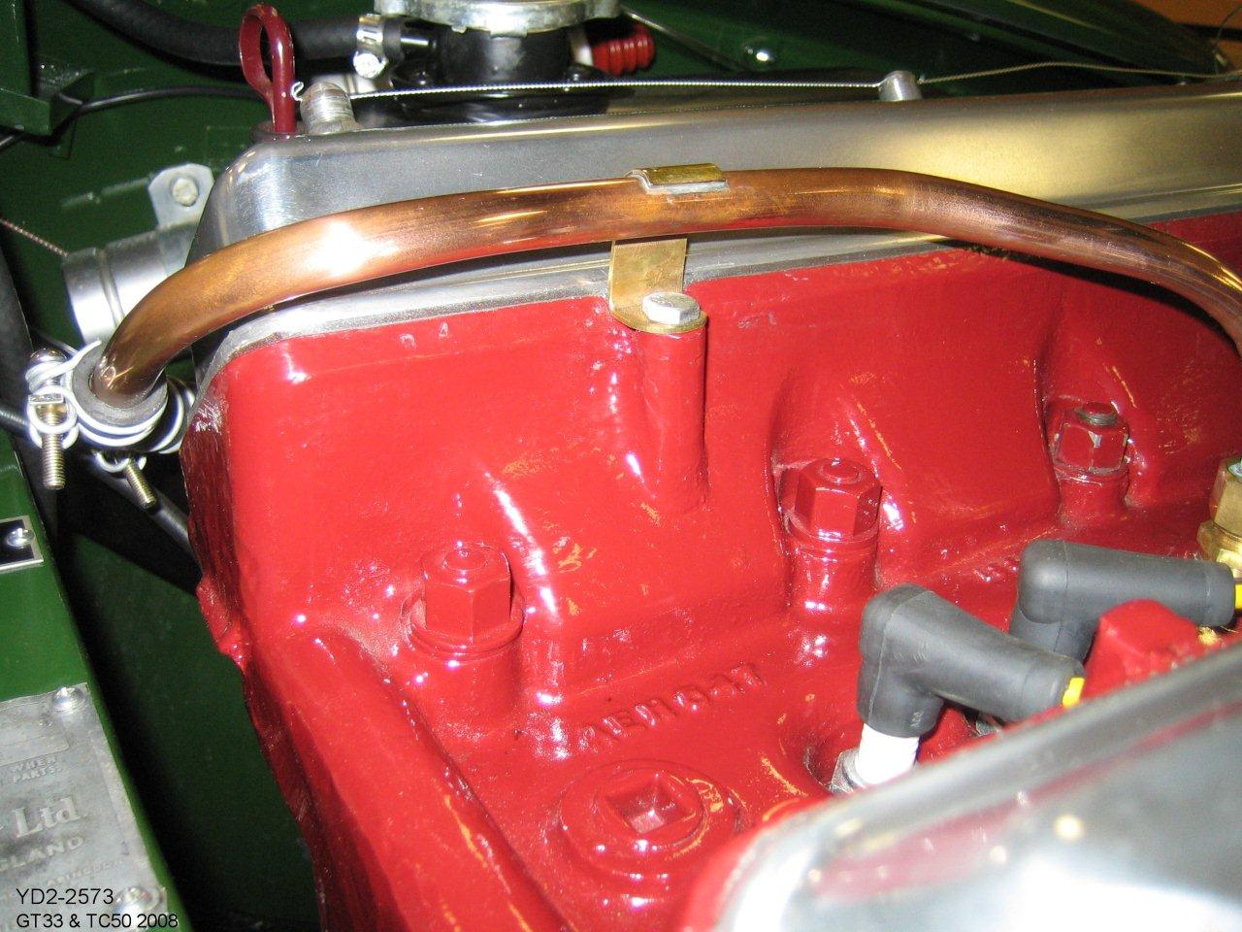

Adjusting Suspension for Track Use.

Anti-Roll Bar.

The fitting of an anti-roll bar as was fitted from chassis number 2275 onward as Standard to the front suspension is recommended. Parts as per page K4 of Service Parts List. See also Service Memorandum MG/278 for more details.
You may find that your front chassis extension required modification however (up to body number ???). Either purchase the later type front extension AHH5924 or have yours modified as shown below.
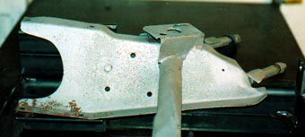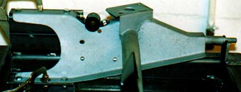

Hydraulic Dampers (Shock Absorbers).
For racing the fitting of higher setting hydraulic dampers is required, this can be down by removing the standard damper valves and fitting higher setting valves as below: Front Part Number BHA4135 2 off
Rear Part Number BHA4136 2 off
Front Settings 1240 rebound, 900 compression, 1030 total leak.
Rear Settings 1800 rebound, 600 compression, 420 total leak.

Uprated valves are still available today from Moss and others as part number AHH7217, said to offer 25% extra stiffness. Also complete unit’s with 50% extra stiffness are available as new complete units.

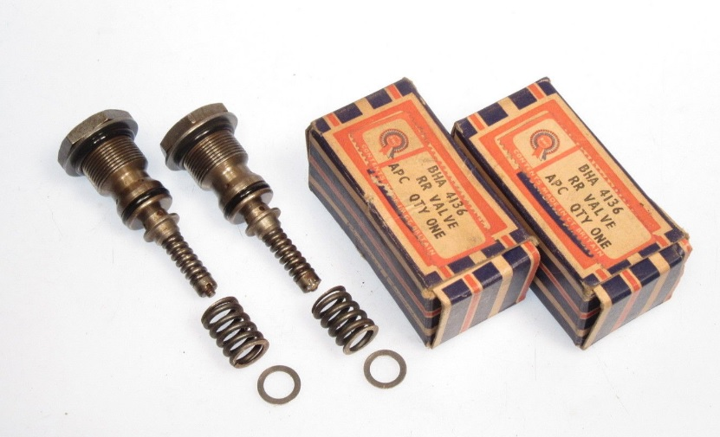

Gearbox & Rear axle.

Rear axle Ratios & Limited Slip Diffs.
The standard axle ratio is 4.3:1. For track use the 4.55:1 maybe found more suitable (Diff. Ass ATB7280 inc crown wheel and pinion ATB7146)
Limited Slip diffs have long been the favorite for racing and fast road cars. Although it’s unlikely to find factory supplied LSD’s these day’s there are several alternatives on offer. Quaif, Moss, Phantom Grip to name but a few.

axle Shafts.
The splines on the axle shafts & differential wheels now are of involuted type. Not separately interchangeable. From Chassis number 2371. See Service Memorandum MG/278.

Gearbox Ratios.
The standard gearbox ratios are 1st 3.6363:1, 2nd 2.2143:1, 3rd 1.3736:1. The close ratio gears are 1st 2.444:1. 2nd 1.618:1, 3rd 1.266:1
Parts required for conversion to close ratio are 1H3297 first motion shaft, 1H3299 2nd speed mainshaft gear, 1H3298 laygear, 1H3300 3rd speed mainshaft gear.

Brakes

Brake Pads
The standard Dunlop brake pads are still availableGBP254, however uprated pads from companies such as Green Stuff, developed for Jaguars are also available.
http://www.powerstop.co.uk/prices.htm

Uprating Rear Brake Cylinders.
With the use of modern radial tires, some breaking efficiencies can be made by upgrading the rear cylinders from the standard. Many racers believe there is too much front bias and too little rear with the standard factory set-up.
 | Bias Front/Rear 67/33  Factory Setup |  | Bias Front/Rear  63/37  Radial tires |  | Bias Front/Rear  60/40  Race with Brake Bias only
Cylinder | Front | Rear | Front | Rear | Front | Rear
Size | 2 1/8 | 1 ½ | 2 1/8 | 1 5/8 | 2 1/8 | 1 ¾
Part No. | 008777 | 08816

Warning: Fitting 1 ¾ rear cylinders, will certainly result in rear brake lockup unless a brake bias system is used. This is not advisable for road cars. 1 ¾ rear cylinders are best suited to race cars with ventilated front rotors with larger non standard pads.

1 5/8” or 1 ¾ “ cylinders are typically sourced from Jaguars and still retain the standard brake pads.

This information has been taken from yahoo article No. 7665 and others.
Also see.
http://www.hyedracyl.com/mg.html

Electronics
Where do I begin, there is so many electronic gizmos out there these days and most serious forms of classic racing ban them anyway.
With Twin Cam engine being very susceptible to over timing. Knock Sensors and electronic distributors can offer reassuring comfort for owners.
Without delving in too deep here, I will just list the topic on the Yahoo site where you can find out more info.
Knock Sensors: 15681 , 15796
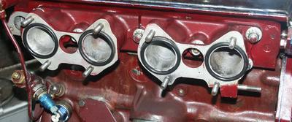
Electronic Ignition:

Appendix
Some useful messages to search for on the Yahoo site:
Please note the performance BHP figures are that quoted by the owner and are undoubtedly from different dyno machines, if at all.

Message 10682 116BHP engine with 2” SU’s
Message 3562 118BHP engine with 10.3CR, 17/57 Cams, +40 overbore
Message 15674 135BHP engine with L14 Cams, Flowed Head
Message 7387 137BHP engine with 40 Webers, Polished head, 9.7 CR, Cams.
Message 14121 140BHP engine with Webers plus extras
Message 13771 140BHP 1762cc engine with Cam’s, 42 Webers
Message 3560 143BHP 1798cc Sleeved, 9.7CR, 40 Webers, Cams
Message 14411 & 7797 160BHP 5 Bearing engine.
Message 10680 177BHP engine with lots of mods
Message 9924 200BHP+ EX181 supercharged

Letter from Mr R Brooklahurat to Alex Hounslow 16/03/1959 with reference to the preparation of a “Tuning Book”
