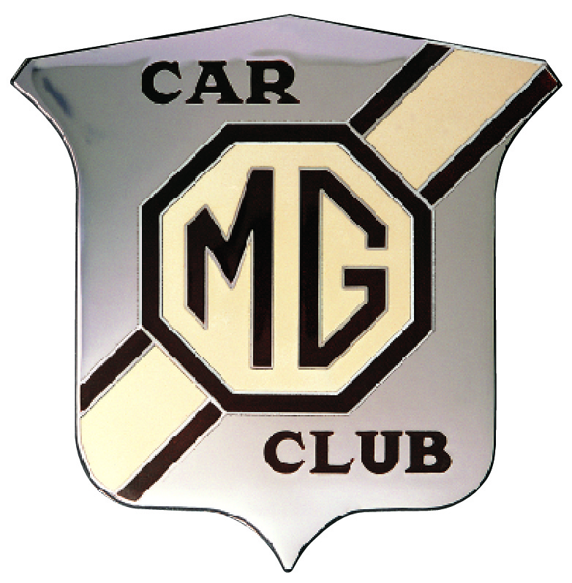
“Pay it Yourself”
Scene by scene analysis
Of Jack Twyford’s films
(The time of each scene is in minutes and seconds from the start of the film)
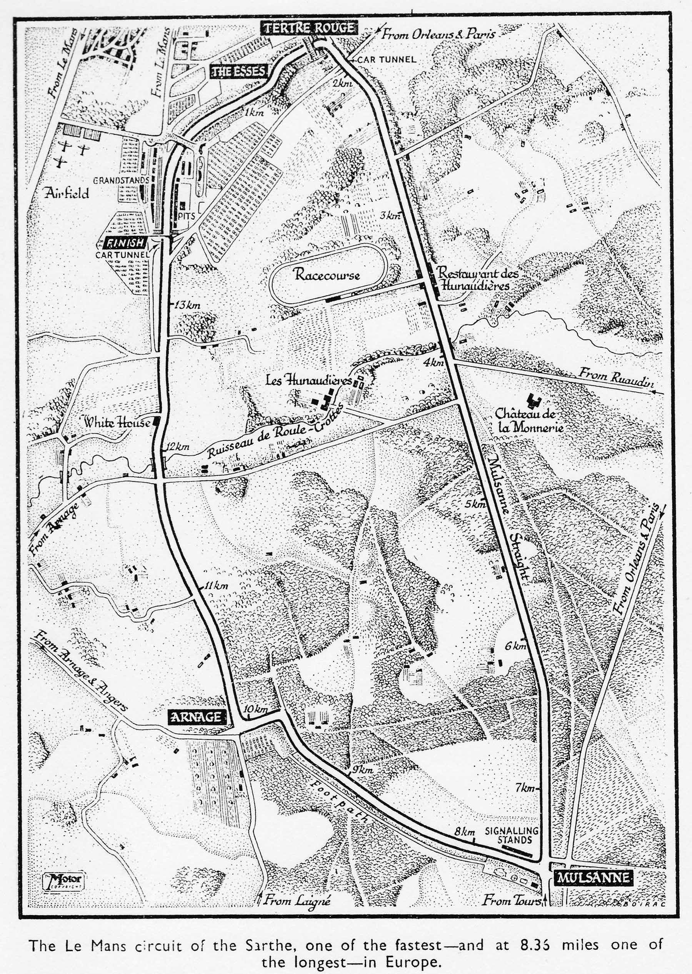
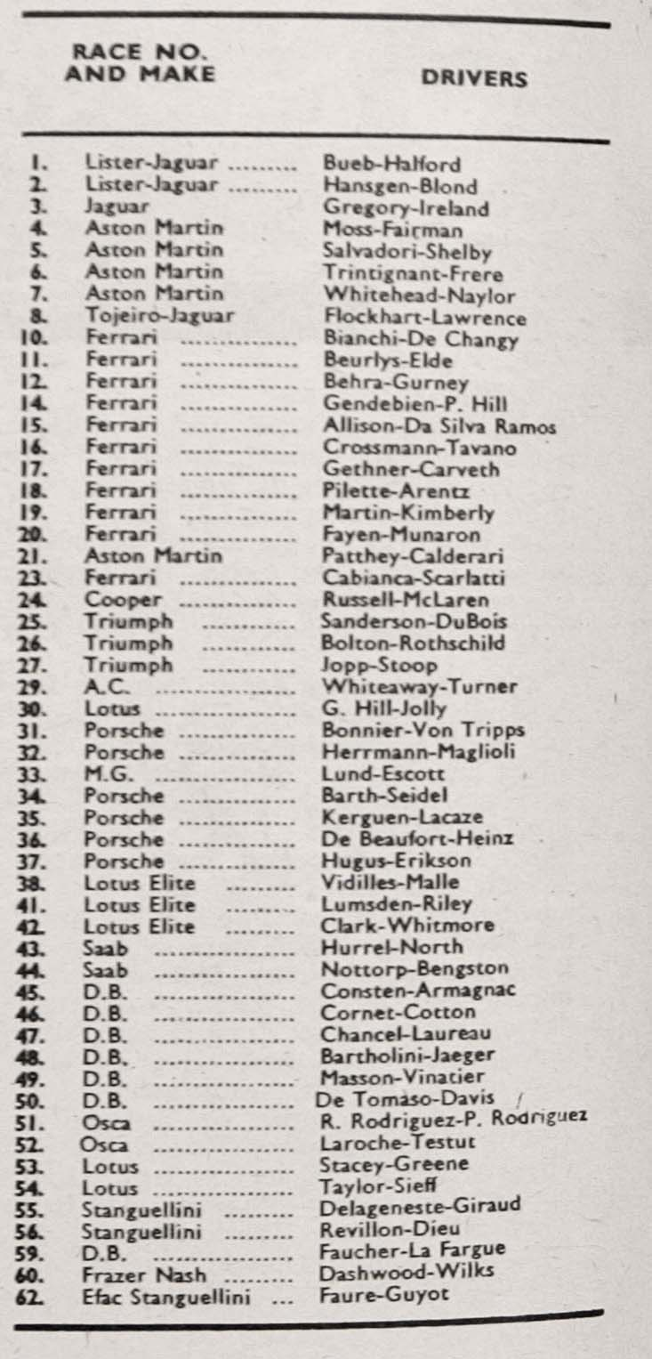
Le Mans 1959 Cars and Drivers
Le Mans 1959
Scene  No. | Start  time | End  time | Description
1 | 00.00 | 00.21 | 1959 Race programme used as opening title
2 | 00.21 | 00.47 | List of cars and drivers from the programme
3 | 00.47 | 01.04 | This might be Iglesia de Saint-Pierre en Caen but the statue in scene 6 is no longer there.
4 | 01.04 | 01.14 | Arnold Pownall (left) and Bill Hogg crossing the road
5 | 01.14 | 01.18 | Original celluloid film broke at this point
6 | 01.18 | 01.38 | Arnold and Bill again followed by street scene
7 | 01.38 | 02.28 | SRX 210 being inspected during scrutineering in Le Mans city centre.
8 | 02.38 | 03.18 | The Court yard at Chateau Chene du Cœur in the village of St. Pavace near Le Mans. Pit crew begins training. Henry Stone checks oil level. This scene is out of sequence, the car has a black stripe across front valance from repairs after damage on the first evening practice.
9 | 03.18 | 03.25 | Colin Escott in the car before 1st evening practice.
10 | 03.25 | 03.35 | SRX 210 drives into city square followed by a Lancia
11 | 03.35 | 04.10 | Car passes through the Inspection Posts, this scene is out of place. Scrutineering happens before any practice and only happens on one day unless a car is rejected. It should be before scene 7.
12 | 04.10 | 04.18 | Arnold Pownall takes a tour of the Le Mans circuit first passing under the Dunlop Bridge just after the start where an Austin-Healey is waiting
13 | 04.18 | 04.27 | Now jumps to the approach to a left hand bend at the Esses.

Scene  No. |  | Start  time |  | End  time |  | Description
14 |  | 04.27 |  | 06.06 |  | Through Tertre Rouge and onto Mulsanne Straight  04.50 passing Restaurant des Hunadiers, 05.06 Scene shift as they have cut out ‘The Kink’ and the ‘Hump’ at Poste 70. A close call with the parked lorry and the approaching car.  05.15 takes Mulsanne corner  05.18 Scene shift to approaching the bend after 8km marker  05.26 Scene shift to bend before Indianapolis  05.35 Arnage, Note: On the public road Arnage is now a Give Way/Stop rather than the priority when the film was taken.  05.43 At the 11km marker.  05.52 approaching White House.  06.06 finish line.
15 |  | 06.07 |  | 07.09 |  | Slower speed lap, now two people in the Healey 06.40 Tertre Rouge.  06.52 Scene shift from before right hander on Mulsanne at 2km to after ‘The Kink’ before the ‘Hump’ at about 6.5km.  07.07 Mulsanne corner
16 |  | 07.09 |  | 07.24 |  | Following SRX 210 and a white MGA on Mulsanne
17 |  | 07.24 |  | 07.31 |  | Evening practice session
18 |  | 07.31 |  | 07.58 |  | Drivers’ briefing. Not possible to identify anyone.
19 |  | 07.59 |  | 08.17 |  | Pits Thursday evening practice. Clock shows 6pm
20 |  | 08.18 |  | 08.28 |  | Ferrari No. 14, Phil Hill on right with Gendebien
21 |  | 08.29 |  | 08.41 |  | Pit scene. Car No 26 is the Triumph of Bolton and Rothschild
22 | 08.42 |  | 08.52 |  | Car No 33 with Colin Escott
23 | 08.53 |  | 09.04 |  | Back at Chene de Coeur, time for a smoke. Lotus 7 in the background
24 | 09.04 |  | 09.35 |  | Cooking supper on a primus stove. Dr Michael King pumping the stove. From left to right, Colin Escott, Ted Lund, Bill Hogg, Arnold Pownall, John King. Female in blue skirt not known

Scene  No. | Start  time | End  time | Description
25 | 09.36 | 10.37 | Team assembles in front of Chene de Coeur for group photograph with the car. Bill Hogg rides a backwards bicycle. At 10.09, Still picture used on front cover of “Pay-it-Yourself”. From left to right: Unknown (possibly Peter Foden), Bill Hogg, George Stott, unknown (possibly Marie Blyth), Colin Escott, unknown, unknown, Ted Lund arms folded, Tommy Wellman, Henry Stone leaning on car, Bobbie Porisse, Wing Commander John King, Heather King, Arnold Pownall, Dr Michael King. At 10.24 Jack Twyford joins the group fourth from right in pink shirt.
26 | 10.37 | 10.48 | Close up of Henry Stone, Arnold Pownall and Colin Escott
27 | 10.48 | 10.55 | Close up of George Stott, Bill Hogg, Bobbie Porisse and Peter Foden
28 | 10.55 | 11.02 | Close up of Dr Michael King and his sister-in-law, Heather King.
29 | 11.02 | 11.06 | Close up of the Morris J2 van
30 | 11.07 | 11.09 | Figures running in chateau courtyard.
31 | 11.10 | 11.19 | MG pit on race day June 20th 1959
32 | 11.20 | 11.29 | General view of pits
33 | 11.30 | 11.41 | Bill Hogg fills up the tank, Bobbie Porisse looks on.
34 | 11.42 | 12.16 | Crowds line the pit straight. Arnold Pownall on the left for the first few seconds, The “Esso Tiger” makes a brief appearance.
35 | 12.16 | 12.33 | Gendarmes line up to clear the track. Renault “Florides” were the featured car this year.
36 | 12.34 | 12.41 | Clock counting down to 4pm start.
37 | 12.42 | 12.47 | Gendarmes salute.
38 | 12.47 | 12.51 | Unknown man speaks to drivers and mechanics
39 | 12.52 | 13.02 | Drivers line up for “Le Mans” start

Scene  No. | Start  time |  | End  time |  | Description
40 | 13.02 |  | 13.38 |  | The start, Ron Flockhart runs across the track and gets away in car no 8 Tojeiro Jaguar. The D Type number 3 (Ireland/Gregory) and Aston Martin DBR1 number 4 (Moss/Fairman) are already on the way. A contemporary ACO photo shows those 2 cars fully on circuit with Flockhart still in his pit box. At 13.35 car no 33 goes past.
41 | 13.39 |  | 13.43 |  | Henry Stone in base ball cap walks along pit lane.
42 | 13.44 |  | 14.14 |  | Cars passing the pits. At 14.04 and 14.11 Car no 33 goes by.
42 | 14.14 |  | 14.31 |  | Shot of the scene behind the pits. Child asleep.
43 | 14.32 |  | 14.37 |  | No 33 passing the pits as night falls
44 | 14.38 |  | 14.49 |  | Pit stop Henry Stone checks under the bonnet
45 | 14.49 |  | 14.55 |  | Close up of Colin Escott
46 | 14.56 |  | 15.05 |  | Pit stop Henry Stone replaces the wire seal on the oil filler cap. The special pliers used by the officials (Plumbeurs) are on the nearside wing.
47 | 15.06 |  | 15.29 |  | Night shots taken from roof of pits, lights of airport and railway visible.
48 | 15.29 |  | 15.55 |  | Camera now at track side
49 | 15.55 |  | 16.17 |  | Scene shift as approach line and background appears to have changed. This scene may be filmed at the signalling pits after Mulsanne corner
50 | 16.18 |  | 16.24 |  | Dawn breaks at Mulsanne corner, No 33 driven by Ted Lund (white helmet) follows No 18 the Works Ferrari of Pilette and Arentz.
51 | 16.25 |  | 17.04 |  | MG support crew at Mulsanne. George Stott bows to camera then hangs out signal board to Ted Lund. Peter Foden (to be confirmed) seated at lap scoring table. The King brothers drinking tea and smoking.
Scene  No. | Start  time |  | End  time |  | Description
52 | 17.04 |  | 17.11 |  | Driving back to the pits through the infield.
53 | 17.12 |  | 17.27 |  | Close up at the pit counter of Arnold Pownall, Henry Stone and Heather King
54 | 17.28 |  | 17.56 |  | Sunday morning. Cars crossing start / finish line
55 |  | 17.57 |  | 18.33 |  | Close up of George Stott, Heather King and Arnold Pownall, then two unknown bystanders.
56 |  | 18.34 |  | 18.46 |  | Car No 48 the Panhard DB of Bartolini and Jaeger in the pits. Helicopter in the background.
57 |  | 18.47 |  | 19.04 |  | Car No 33 approaches its pit. Ted Lund (white helmet) gets out. The front end of the car is already damaged by the accident with the Alsation dog at Mulsanne when Colin Escott was driving.
58 |  | 19.05 |  | 19.35 |  | Ted Lund has breakfast cooked by Heather King at the back of the pits. Arnold Pownall takes a look.
59 |  | 19.35 |  | 19.39 |  | Clock shows 9.50 am as Colin Escott completes another lap with Car No. 33
60 |  | 19.40 |  | 19.54 |  | Crowd scene showing the food stalls
61 |  | 19.55 |  | 20.28 |  | Camera has moved to the outside of the circuit beyond the Dunlop Bridge. Helicopter again in shot.
62 |  | 20.29 |  | 20.44 |  | Camera now in Grandstand opposite the pits
63 |  | 20.45 |  | 20.58 |  | Car No.55 the 740cc Stranguellini of Delageneste and Giraud going very slowly. This car finished the race in 13th and last place.
64 |  | 20.59 |  | 21.16 |  | Grandstand again. No 45 a Panhard finished 11th.
65 |  | 21.17 |  | 21.25 |  | Colin Escott in Car No 33
66 |  | 21.26 |  | 21.30 |  | Car No 49 a Panhard coming in.
67 |  | 21.31 |  | 21.41 |  | Car No. 14 a Ferrari driven by Hill and Gendebien stopped after 263 laps.
68 |  | 21.42 |  | 21.49 |  | Time keepers clock shows 10.30, the end of the race for Car No. 33
69 |  | 21.50 |  | 22.00 |  | A shot of Jack Twyford’s cine camera on a tripod brings the 1959 film to an end.

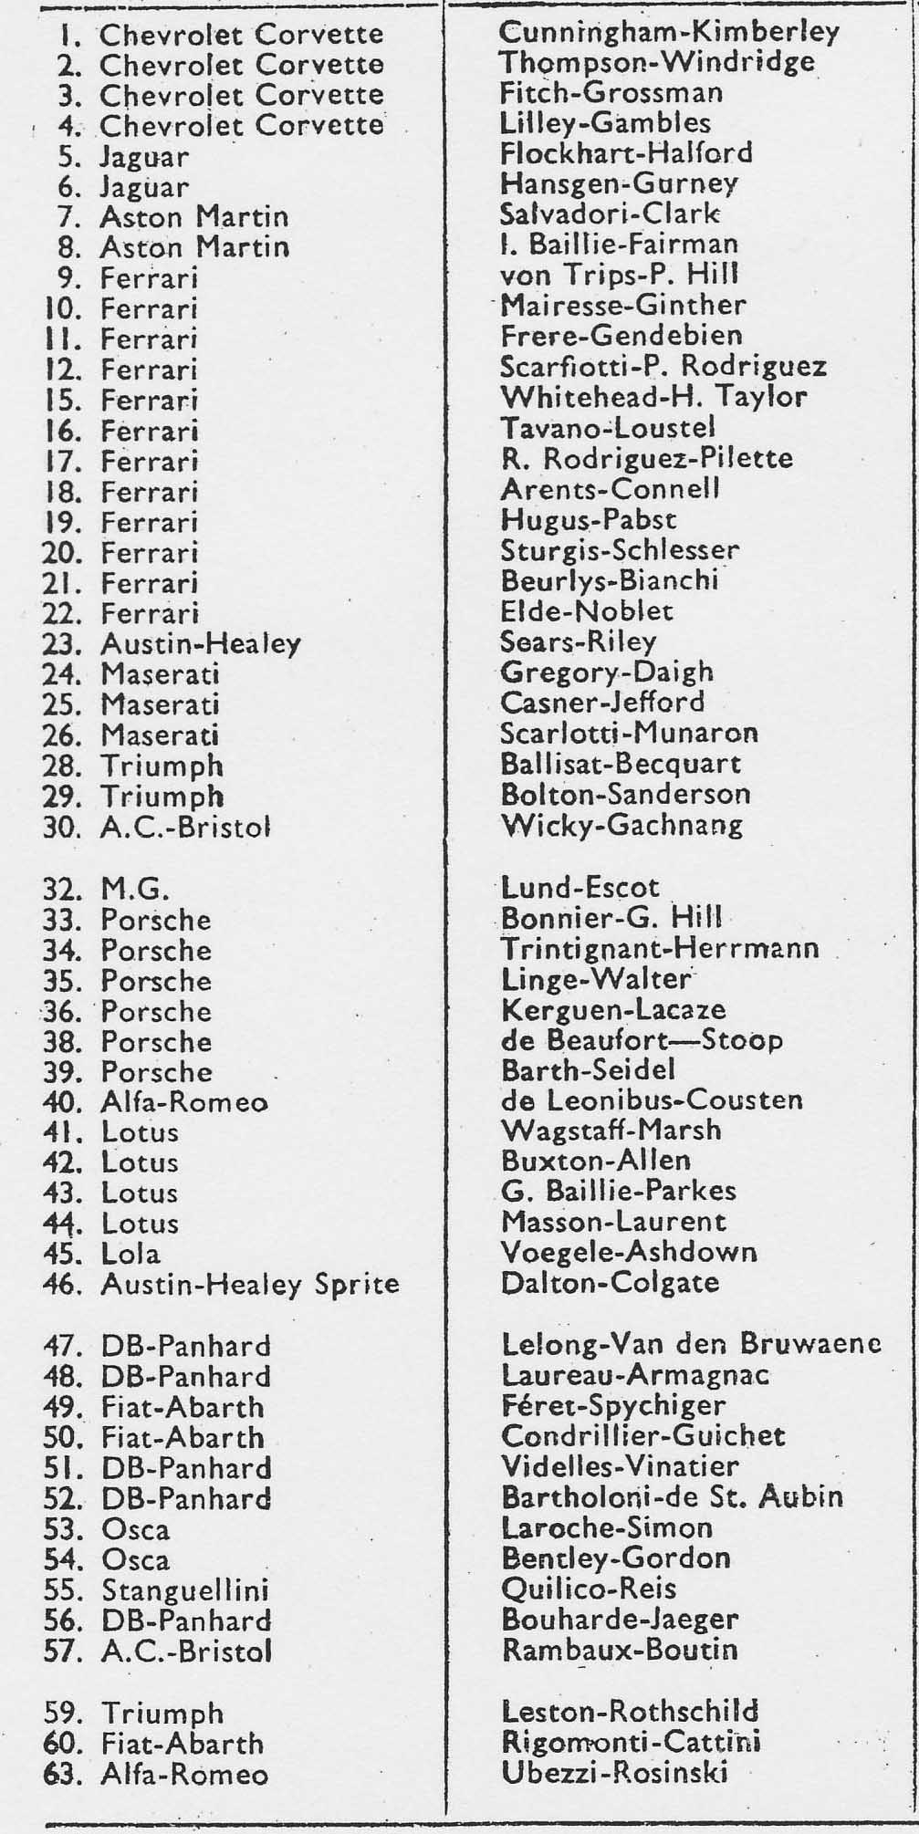
Le Mans 1960 Cars and Drivers
Le Mans 1960
Scene  No. | Start  time | End  time | Description
1 | 00.00 | 00.10 | Sarthe Circuit entrance used as opening title
2 | 00.11 | 00.22 | Ted Lund in cowboy hat with Arnold Pownall and Hugh Whiteside polish Car No. 32. Arnold’s blue Jaguar parked nearby. They are outside the Café des Promenades in the Place des Jacobins outside the scrutineering area.
3 | 00.23 | 00.46 | Car No 32 and the Jaguar arrive at pre race inspection in La Place de La Republic, Le Mans.
4 | 00.47 | 01.07 | Ted Lund and the team take the car through the inspection stages. At 01.06 David Lomas in red shirt faces the camera.
5 | 01.08 | 01.31 | Car No. 32 wheeled into scrutineering area and pushed onto the ramp. Ralfe Graveley, then age 19 in blue shorts.
6 | 01.32 | 01.39 | Car No. 32 moving between the inspection checks
7 | 01.40 | 01.48 | Wendy Escott takes Colin’s photograph. Bill Hogg looks on.
8 | 01.48 | 01.56 | Car No. 32, Ted Lund still in his cowboy hat, he had been at Sebring in the USA a few weeks earlier.
9 | 01.56 | 02.11 | From left to right, close up of John Graveley, Rodney Bloor (red shirt), Bill Hogg, Sue Graveley, Colin Escott, Wendy Escott, Ralfe Graveley, Geoff Lomas, David Lomas and Bill Hogg again
10 | 02.11 | 02.42 | Draining the petrol tank. Arnold Pownall puts it into his own car then chases the small boys away. Are these “The experts” seen in Pay-it-Yourself page 44?
11 | 02.43 | 03.17 | Car No. 32 pushed onto weighbridge to be weighed “dry”, then to petrol tanker to be filled with approved fuel.
12 | 03.18 | 03.24 | Veteran car of unknown make. Registered in Le Mans 588CW72
Scene  No. | Start  time | End  time | Description
13 | 03.25 | 03.47 | MG team enjoy a drink at a pavement cafe
14 | 03.48 | 03.55 | Ted Lund works on his suntan wearing a woollen hat.
15 | 03.56 | 04.17 | Lucas support van. Possibly a Lucas technician working on part of the car watched by Mike Seddon and Henry Stone.
16 | 04.18 | 04.50 | Bill Hogg plays bull fighter with a calf in the grounds of the team H.Q. “Les Cailleres” a large house in the village of St. Pavace on the outskirts of Le Mans. The Lucas support van in the background at the start of the scene.
17 | 04.51 | 05.12 | Team preparing to leave “Les Cailleres”
18 | 05.13 | 05.39 | At the pits for an evening practice session. Car No. 6 at the next pit is the Jaguar entered by Briggs Cunningham, driven by Hansgen and Gurney.
19 | 05.40 | 05.59 | Car No. 32 taking the Esses.
20 | 06.00 | 07.18 | Drivers briefing. At 06.40 Jim Clark in green shirt comes into shot. Briefing appears to be concerned with pit entry and exit
21 | 07.19 | 07.31 | The pits again for second evening practice. Car No. 7 is the Aston Martin (Reg. No. FSH 360) entered by Border Reivers, driven by Clark and Salvadori. They finished third. The red and white car in front of 7 is 30 the AC Bristol which finished but was not classified.
22 | 07.32 | 08.17 | MG pit looking relaxed. At 07.54 is this Lofty England, a tall man talking to Colin Escott? Ted Lund, white helmet and red short sleeved shirt gets into Car No. 32.
23 | 08.18 | 08.25 | Car No. 9 the Works Ferrari of Von Tripps and Hill leaves the paddock as Car No. 32 drives by.
24 | 08.26 | 08.57 | Camera moves to the outside of the circuit. Car No 57 is the AC Bristol of Rambaux and Boutin.

Scene  No. | Start  time | End  time | Description
25 | 08.58 | 09.11 | Back at “Les Cailleres” some last minute work is needed. Colin Escott’s red MGA Coupe KEN 65 in the background.
26 | 09.12 | 10.07 | Team line up for the official photograph. From left to right, Hugh Whiteside, Bill Hogg, George Stott, Rodney Bloor (reserve driver), David Lomas, Mike Seddon, Roger Pilkington, Henry Stone (MG works mechanic), Ted Lund, unknown, Michael King, John King, Geoff Lomas, Heather King, Don Thompstone, Arthur Collins, Arnold Pownall, Jack Twyford.  At 09.40 a young man, James Gerrard comes out of the door behind the group. He was a friend of David Lomas and Mike Seddon.
27 | 10.08 | 10.19 | Close up of Arnold Pownall and Jack Twyford in matching outfits.
28 | 10.20 | 10.40 | This is the group photograph featured on the back cover of “Pay-it-yourself”.
29 | 10.41 | 10.44 | Colin Escott talking to Peter Foden
30 | 10.45 | 10.50 | Henry Stone, Roger Pilkington and Ted Lund
31 | 10.51 | 10.57 | Mike Seddon and Geoff Lomas
32 | 10.58 | 11.03 | George Stott
33 | 11.04 | 11.16 | Arnold Pownall and the calf.
34 | 11.16 | 11.19 | The Stott Arms
35 | 11.20 | 11.43 | Driving into the circuit on race day Saturday 25 June 1960
36 | 11.44 | 11.55 | The MG pit crew prepare their car
37 | 11.56 | 12.01 | Colin Escott taking photographs
38 | 12.02 | 12.18 | The pit lane
39 | 12.19 | 12.30 | Ted Lund in woolly hat with Colin Escott behind the pits. Bill Hogg walks into the pit with his Ford ET6 lorry in the background.
Scene  No. | Start  time | End  time | Description
40 | 12.31 | 12.37 | Colin Escott demonstrates the driver’s drinking tube
41 | 12.37 | 12.45 | Motoring journalist John Bolster in his characteristic deerstalker hat.
42 | 12.46 | 13.03 | View of the pits with the team Ferrari cars arriving
43 | 13.04 | 13.11 | Gendarmes
44 | 13.12 | 13.29 | Car No. 22 the Ecurie Francorchamps Ferrari of Elde and Noblet, they finished sixth. The two white cars are Corvettes 1 and 2, neither finished. John Bolster seen again in this scene.
45 | 13.30 | 13.57 | Colin Escott and friends in the tent at the back of the pits. At 13.41 the only shot of Rex Normanton
46 | 13.58 | 14.06 | Final checks on the car.
47 | 14.07 | 14.23 | Grandstands now full ready for the start.
48 | 14.24 | 14.31 | Bill Hogg fills the tank.
49 | 14.32 | 14.56 | A band leads the parade of the national flags of all the teams.
50 | 14.57 | 15.23 | Gendarmes clear the track as the crowd on the terraces opposite the pits get ready for the start
51 | 15.24 | 16.17 | The “Le Mans” start. The “Tricolour” falls at 15.33. At 15.45 the Salvadori/Clark Aston Martin DBR1 number 7 can be seen leading the pack. Cars 1,2,3 and 4 are the Chevrolet Corvettes of the Briggs Cunningham team. At 16.09 Car No. 32 goes past
52 | 16.18 | 16.31 | Cars passing the pits during the early laps.
53 | 16.32 | 16.46 | The MG pit as No 32 completes another lap.
54 | 16.47 | 17.53 | Camera moves to Maison Blanche.  1st shot Exiting from White House complex, camera on inside of circuit  2nd Camera on exit of left hander out of White House  3rd Camera now before White House showing the right and left handers. 4th Same position but looking the other way.
Scene  No. | Start  time | End  time | Description
55 | 17.54 | 18.01 | 1 On the run down from where nowadays the Porsche Curves go off towards the Route du Ruaudin D92.  2 Closer to top of hill and now standing on the banking. This would have been filmed between 6 and 7 pm, the Ferrari retired on lap 12 in the 3rd hour.
56 | 18.02 | 18.10 | Inside of circuit, opposite le Grille, at about the 11km marker where the current circuit turns into Porsche Curves, looking towards Arnage
57 | 18.10 | 18.14 | Same camera position as scene 56 but looking towards White House. A nice piece of splicing to move the MG from dry to wet as night falls late on Saturday.
58 | 18.15 | 19.00 | Night time shots of the cars passing and the BP sign with the clock counting down the 24 hours. The name of the leading car changes from Ferrari to Jaguar. At 19.52 the pit board at Mulsanne, and cars exiting from the corner.
59 | 19.01 | 19.10 | Dawn on Sunday 26 June. Camera remains at Mulsanne signal station. The MG board shows “T 5 05”. This may have been the lap time, their fastest lap was 5 minutes 3.8 seconds. An abandoned car on the left.
60 | 19.11 | 19.15 | Close up of one of the King brothers and his wife
61 | 19.16 | 19.24 | Close up of George Stott drinking tea as he records lap times.
62 | 19.24 | 19.30 | A helper makes tea for the crew.
63 | 19.31 | 19.48 | Lap scorers at work.
64 | 19.49 | 19.55 | Pit board showing “T 5 02”. Was this a target time?
65 | 19.55 | 20.00 | Tea break over.
66 | 20.00 | 20.24 | Two great shots of Car No. 32 slowing at the end of the Mulsanne Straight then pulling away from the corner. You can see the ‘Hump’ at Poste 70.

Scene  No. | Start  time | End  time | Description
67 | 20.25 | 20.41 | Joyce Woolley relaxes with the morning paper then answers the phone at the signal station.
68 | 20.42 | 20.56 | Looks like car number 7 the Salvadori/Clark Aston Martin DBR 1 in for a pit stop. The large brass pump contains the engine oil.
69 | 20.57 | 21.00 | Close up of John Graveley
70 | 21.01 | 21.15 | Close up of Arnold Pownall, Joyce Woolley and Roger Pilkington
71 | 21.16 | 21.22 | Close up of Hugh Whiteside laughing
72 | 21.23 | 21.34 | Close up of Henry Stone
73 | 21.35 | 21.44 | Daylight now as Car No. 32 passes the pits
74 | 21.45 | 22.55 | Car No. 32 comes in for a routine pit stop. The race official gives the OK to cut the locking wire on the oil filler cap. Bill Hogg pumps the petrol. Henry Stone cleans the windscreen then the car is held by the officials until the track is clear.
75 | 22.55 | 23.02 | Car no. 32 leaves the pits again. Bright sunshine now and stands are full.
76 | 23.03 | 23.09 | A conference at the back of the pits
77 | 23.10 | 23.22 | Car No. 48 the DB Panhard of Laureau and Armagnac in for a pit stop. They finished 17th.
78 | 23.23 | 24.36 | Action shots of Car No. 32 filmed at the Esses. At 23.40 a GT Ferrari goes by. At 23.56 one of the Corvettes. No. 4. At 24.29 Car No. 35 a Porsche which finished 11th. At 23.34 Aston Martin No. 7 followed by an unknown blue car.
79 | 24.36 | 24.44 | Car No. 32 approaching Tertre Rouge
80 | 24.44 | 24.54 | Exit from Tertre Rouge onto Mulsanne Straight
81 | 24.55 | 25.13 | Arnold Pownall standing on the pit counter
82 | 25.14 | 25.28 | The whole crew on the counter, John Graveley turns to look at the camera.
Scene  No. | Start  time | End  time | Description
83 | 25.28 | 25.41 | Car No 3 the Corvette of Fitch and Grossman leaves the pits. They finished 8th. Lots of shouting and arm waiving from the other pit crews.
84 | 25.42 | 26.15 | Car No. 32 makes another pit stop
85 | 26.15 | 26.31 | Susan Graveley, Bill Hogg, Ralfe Graveley and others all looking anxious.
86 | 26.31 | 26.34 | Corvette No. 3 takes on water.
87 | 26.35 | 26.49 | Colin Escott brings No. 32 in for a final time removing his red seat cushion as he gets out of the car.
88 | 26.50 | 27.20 | 4pm on Sunday 26 June, the chequered flag is out for the finishers.  At 26.57 Car No 3 finishes 8th.  At 27.01 the three Triumphs finish in line abreast but none qualified for a place as they failed to cover the minimum distance.  At 27.05 Salvadori /Clark Aston Martin No. 7 finishes 3rd followed by the unclassified Corvette No. 4  At 27.16 Ted Lund crosses the line side by side with the Austin-Healey Sprite Car No. 46 driven by John Dalton and John Colgate.  The MG finished 12th overall and 1st in the two litre class. The Sprite finished 16th overall and 1st in the one litre class.

